**Drag & Drop**

## A Project Report

### Submitted in partial fulfillment of the requirements for the award of the degree of

**Master of Computer Application**

## Submitted By Akhil Verma

**(University Roll No.: 1900290140004) Batch: 2019-2022**

## Under the supervision of Miss Neelam Rawat (Associate Professor)



**DEPARTMENT OF COMPUTER APPLICATIONS DR.APJ ABDUL KALAM TECHNICAL UNIVERSITY LUCKNOW**

## (Formerly Uttar Pradesh Technical University, Lucknow) (JUNE 2022)

Signature Signature

(Name of Student) (Name of Mentor)

## DISSERTATION REPORT ON

**Drag & Drop**

## SUBMITTED BY : Akhil Verma

IN PARTIAL FULFILLMENT OF

THREE YEAR MASTER OF COMPUTER APPLICATIONS PROGRAMME



## DR.APJ ABDUL KALAM TECHNICAL UNIVERSITY LUCKNOW

External Supervisor: Internal Superv*isor:*

**Mr. Kushagra Mishra (Tech Lead), Miss Neelam Rawat**

**Cloud Analogy Softech Pvt. Ltd, KIET,Ghaziabad**

**Mohali.**

## DECLARATION

Certified that **Akhil Verma**, **1900290140004**, has carried out the research work presented in this project report entitled **“Eco|PRIME”** at Cloud Analogy from February, 2022 to PRESENT, under the supervision of Mr. **Kushagra Mishra (Tech Lead), Cloud Analogy Softech Pvt. Ltd.** and **Miss Neelam Rawat Assistant Professor, KIET Group Of Institutions**, is a record of original work for the partial fulfillment of the requirements for the award of the degree, **MCA** (Master of Computer Application).

#### Name: Akhil Verma Enrolment

**No.:**1900290140004

Signature:

## CERTIFICATE

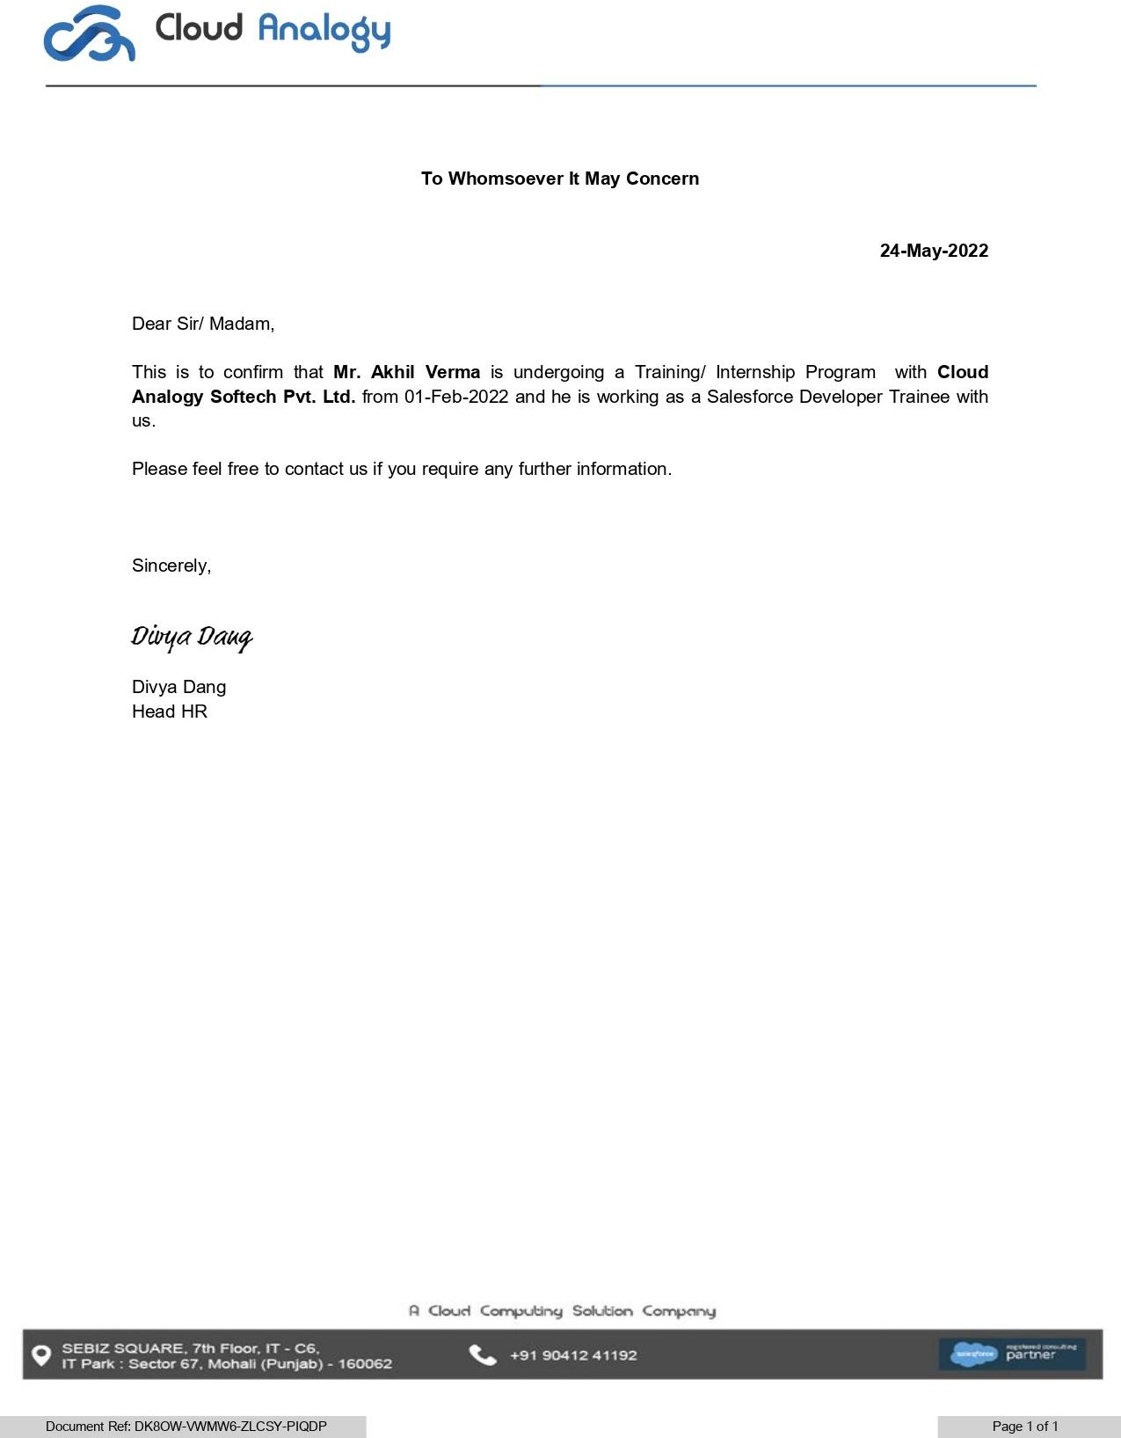

**ABSTRACT**

eco|Prime is name of a brand that had been made to fulfil the system

requirements of an educational organization by the students of KIET. The name ECO | PRIME had come from a reason that had both technical and environmental meaning.

The word eco|Prime in technical term that is Enterprise Coded Object

and PRIME represent Power. Its whole functionality is based on objects that had been written in order to accomplish the work of an educational organization. The work of eco|Prime is based on objects that defines the technical functionality of organization.

On the other hand eco|Prime is related to environment concept that is ECO, related to ecology/ environment defines the reduction of paper work as well as promotion of Digital India in the field of Information Technology. This software had contributed towards less paper use so that wastage of environmental resources can be reduced.

## ACKNOWLEDGEMENT

I would like to extend my gratitude to my teachers and my Training and Placement Department as because of them only I was allowed to pursue an internship in my Final Semester. I would like to credit them for guiding me to receive and to carry out my Internship Cloud Analogy, Mohali.

I would like to thank all my professors and fellow batch mates who helped through every phase of the 3 years of my life which I consider to be one of the most important and crucial years.

This work would not have been possible without the support of my supervisors under Mr. Kushagra Mishra (Tech Lead) for the Salesforce Developer Trainee Role at Cloud Analogy, Mohali for constantly having faith in me and giving me the freedom to work on desired projects and being honest and critical to my performance.

# CHAPTER 1 INTRODUCTION

Drag & Drop is a Salesforce App which is created by Cloud Analogy Softech Pvt. Ltd. It is

made for both Classic and Lightning experience parts of salesforce. Drag & Drop provide many facilities by which one can work efficiently, effectively and saves lots of time.

Drag & Drop is easy to install and configure. Some Features of Drag &Drop are following:

## FEATURES OF DRAG AND DROP

**Any Object Configuration** – It Works for all the standard and custom object. It is a generic app which works for any object in Salesforce let it be Account, Contact etc.

**Drag and Drop** – Salesforce by default allow you upload a file. Click on the file, select It, then upload it. But in our particular case, we have created an awesome section to drag and drop, all the file I want to upload. When file automatically drags and drop it will automatically get assembled in multiple pages.

**Delete Multiples**- To delete files one by one is tie taken and boring but in drag and drop, a person can select multiple files and can delete them simultaneously.

**Downloads Multiple Attachments**- There are many times when one can want to download multiple files. Go head multiple select and download them.

All these features are very helpful for day-to-day admin work or a sales guy who is managing or doing a lot of attachment work.

Drag and Drop feature is here to ease the Add Attachment functionality. Now you can add Attachment to any Object in Salesforce by just a click or dragging and dropping it into your Windows’ Browser.

Drag and drop is a functionality by which users can select an object or a section of text and can move it to a desired location and "drop" it there. Drag and drop is a part of graphical user interfaces, but is not found in all software.

Using the drag and drop method is intended to be simple for users to move or copy items. In order to perform this action, the user must highlight the text or select the object to be moved, then press and hold down the left mouse button to grab the object. The user then drags the object to the desired location, while still holding down the mouse button. When the mouse button is released, it "drops" the object in that location, either moving or copying it, depending on the program.

Drag and drop (also "drag-and-drop") is a common action performed within a graphical user interface. It involves moving the cursor over an object, selecting it, and moving it to a new location.

If you are using a mouse, you can drag and drop an object by clicking the mouse button to select an object, then moving the mouse while keeping the mouse button pushed down. This is called "dragging" the object. Once you have moved the object where you want to place it, you can lift up the mouse button to "drop" the object in the new location. If you are using a touchscreen device, you can select an item by simply touching it with your finger. (Some interfaces may require you to hold your finger on the object for a second or two to select it.) Then you drag the item by moving your finger across the screen to the location where you want to place it. To drop the object, simply lift your finger off the screen.

Drag and drop can be used for multiple purposes. For example, you can drag and drop an icon on the desktop to move it to a folder. You can drag and drop an open window by clicking the title bar and moving it to a new location. Some programs allow

you to open files by dragging and dropping file icons directly onto the application icon. Many programs allow you to customize the workspace by dragging and dropping interface elements in different locations on the screen. Computer games, like chess, typically allow you to move objects in the game using a drag and drop action.

In computer graphical user interfaces, drag and drop is a pointing device gesture in which the user selects a virtual object by "grabbing" it and dragging it to a different location or onto another virtual object. In general, it can be used to invoke many kinds of actions, or create various types of associations between two abstract objects.

As a feature, drag-and-drop support is not found in all software, though it is sometimes a fast and easy-to-learn technique. However, it is not always clear to users that an item can be dragged and dropped, or what is the command performed by the drag and drop, which can decrease usability.

Dragging requires more physical effort than moving the same pointing device without holding down any buttons. Because of this, a user cannot move as quickly and precisely while dragging (see Fitts' law). However, drag-and-drop operations have the advantage of thoughtfully chunking together two operands (the object to drag, and the drop location) into a single action.[2] Extended dragging and dropping (as in graphic design) can stress the mousing hand.

A design problem appears when the same button selects and drags items.

Imprecise movement can cause a

Another problem is that the target of the dropping can be hidden under other objects. The user would have to stop the dragging, make both the source and the target visible and start again. In classic Mac OS the top-of-screen menu bar served as a universal "drag cancel" target. This issue has been dealt with in Mac OS X with the introduction of Exposé.

Drag and drop is considered an important program construction approach in many end-user development systems. In contrast to more traditional, text-based programming languages, many end-user programming languages are based on visual components such as tiles or icons that are manipulated by end users through drag-and-drop interfaces. Agent Sheets, a programming environment for kids, introduced the modern notion of drag and drop blocks programming providing 4 core affordances:

1. Blocks that are end-user composable,
2. Blocks are end-user editable,
3. Blocks can be nested to represent tree structures,
4. Blocks are arranged geometrically to define syntax.

Drag and drop is also featured in many shader editing programs for graphics tools, such as Blender. Drag and drop also features in some video game engines, including Unreal Engine, Game Maker Studio, Construct 2 and, with expansion, Unity (game engine).

A common example is dragging an icon on a virtual [desktop](https://en.wikipedia.org/wiki/Desktop_environment) to a special [trashcan](https://en.wikipedia.org/wiki/Trashcan) [icon](https://en.wikipedia.org/wiki/Icon_(computing)) to delete a [file](https://en.wikipedia.org/wiki/Computer_file).

Further examples include:

* Dragging a data [file](https://en.wikipedia.org/wiki/Computer_file) onto a [program](https://en.wikipedia.org/wiki/Computer_program) [icon](https://en.wikipedia.org/wiki/Icon_(computing)) or window for viewing or processing. For instance, dropping an icon that represents a text file into a Microsoft Word window signifies "Open this document as a new document in Word"
* Moving or copying [files](https://en.wikipedia.org/wiki/Computer_file) to a new location/directory/folder,
* Adding objects to a list of objects to be processed,
* Rearranging [widgets](https://en.wikipedia.org/wiki/Widget_(computing)) in a [graphical user interface](https://en.wikipedia.org/wiki/Graphical_user_interface) to customize their layout,
* Dragging an attribute onto an object to which the command is to be applied,
  + e.g. dragging a color onto a graphical object to change its color,
* Dragging a tool to a canvas location to apply the tool at that location,
* Creating a [hyperlink](https://en.wikipedia.org/wiki/Hyperlink) from one location or word to another location or document.
* Most word processors allow dragging selected text from one point to another.
* Dragging a series of code blocks such as in [Blender](https://en.wikipedia.org/wiki/Blender_(software)) for designing shaders and materials.

One of the great challenges of Interaction Design these days is that we now have a plethora of new ways to design interaction on the web than we did just a few short years ago. Drag and drop is probably one of the best – creating a sense of empowerment over the interface that can sometimes result in an almost joyful user experience.

Despite the fact that we’ve been designing with drag and drop for a while now, it’s taken this long for me to have the opportunity to do some good solid user testing with users comparing drag and drop with more traditional interaction styles. That is … clicking :)

In the test that were we performing we were (amongst other things) examining the use of drag and drop and clicking to perform two types of tasks: to select objects and place them onto a stage, and to manipulate objects on a stage.

One interface used drag and drop for both tasks. One interface used click to select and drag n drop to manipulate.

When users were interacting with the prototype that used drag and drop for both functions it was common for them to make unsolicited comments about the interface – generally expressions of delight at the responsiveness of the interface and the novelty of the interaction method. Of course, drag and drop is not really, so novel – many users are accustomed to this method, and we found that no users (of the 15 we tested) were unfamiliar with the drag and drop method or had any difficulties understanding how they were expected to achieve their task using drag and drop. (The interface did include a small instruction to drag and drop onto the stage).

Some of the tasks, such as removing objects from the stage and understanding how many objects could be dragged onto the stage were not immediately obvious, but through brief experimentation, the users were rapidly able to achieve these tasks and exhibited no difficulty. In fact, in many cases they were saying ‘I wonder if I drag this back here will it delete the object’, as they performed the task and were pleased to discover that it worked exactly as they had expected it might.

When users were interacting with the ‘click to select’ interface, there were no such expressions of delight with the interaction, however they also had no difficulty achieving all of the tasks involved in the test.

Later, we asked the users to compare the two interaction experiences and talk about which they preferred and why. Without exception, we found that our test participants preferred the click to select interface over the drag and drop interface – despite the feedback they had given at the time of testing.

They agreed that drag and drop felt ‘fun’, and ‘creative’, but overwhelmingly stated that it was unnecessarily complicated, and that it was just as easy, or easier, to click. ‘Dragging was a drag’ was one of my favourite quotes. :)

On the other hand, users unanimously agreed that drag and drop was an ideal way to manipulate objects in relation to each other (particularly, to change the position of objects in relation to one another).

Based on the results of this testing, the logical findings seem to be that drag and drop is ideal for manipulating the position of objects on a stage, but that when ‘selecting’ objects, simply using click to select is preferable. Even considering that we may be wishing to create an interface that is fun and creative (which was why the full drag and drop approach was originally considered), the inefficiency of this method detracts from the user performing their

task. Selecting the objects was considered a preliminary task, and the ‘fun’ part started when users got to manipulating the content.

When thinking of the best examples of drag and drop interfaces (and I think that moving around maps is a great example of this), it is once again the manipulation of objects on a stage and not object selection, that seems to be common.

Of course, it is also important to note that choosing a drag and drop interface also significantly compromises your ability to deliver an accessible interface. This should always be an important consideration when selecting an interaction method.

Designing a drag and drop interface. You could do much worse than refer to the [Yahoo! Design Pattern Library](http://developer.yahoo.com/ypatterns/parent.php?pattern=dragdrop) where they have spent a lot of time thinking about all of the components of the interaction and what you will need to consider.

Have you done any testing with drag and drop interfaces? I would be interested to hear what you have found.

## 1.1 System Configuration

* + 1. **Developing Environment Hardware Requirements Client Side**
       - Processor i3 or above
       - Hard Disk 500GB or above
       - Ram 3GB or above
       - Peripheral Devices:-

− Keyboard

− Mouse

#### Server Side

* + - * Processor i3 or above
      * Hard Disk 500GB or above
      * Ram 3GB or above Peripheral Devices:-

− Keyboard

− Mouse

## Software Requirements

## Client Side

* Browser (Google Chrome Or Mozilla Firefox)
* Operating System (Windows 7 or above)

## Server Side

* Browser (Google Chrome Or Mozilla Firefox)
* Operating System (Windows 7 or above)

## Implementing Environment

## Hardware Requirements

#### Client Side

* Processor i3 or above
* Hard disk 500GB or above
* Ram 3GB or above
* Peripheral Devices:

− Keyboard

− Mouse

#### Server Side

* Processor i3 or above
* Hard disk 500GB or above
* Ram 3GB or above
* Peripheral Devices:

− Keyboard

− Mouse

## Software Requirements

#### Client Side

* Browser (Google Chrome or Mozilla Firefox)
* Operating System (Windows 7 or above)

#### Server Side

* Browser (Google Chrome or Mozilla Firefox)
* Operating System (Windows 7 or above)

# Project Schedule

## Gantt Chart

A Gantt chart is a type of bar chart, adapted by Karol Adamiecki in 1896 and independently by Henry Gantt in the 1910s, that illustrates a project schedule. Gantt charts illustrate the start and finish dates of the terminal elements and summary elements of a project. Terminal elements and summary elements comprise the work breakdown structure of the project. Modern Gantt charts also show the dependency (i.e., precedence network) relationships between activities. Gantt charts can be used to show current schedule status using percent-complete shadings and a vertical "TODAY" line as shown here.

Although now regarded as a common charting technique, Gantt charts were considered revolutionary when first introduced. This chart is also used in information technology to represent data that has been collected.

A Gantt chart is a horizontal bar chart developed as a production control tool in 1917 by Henry L. Gantt, an American engineer and social scientist. Frequently used in project management, a Gantt chart provides a graphical illustration of a schedule that helps to plan, coordinate, and track specific tasks in a project.

A Gantt chart, commonly used in project management, is one of the most

popular and useful ways of showing activities (tasks or events) displayed against time.

On the left of the chart is a list of the activities and along the top is a suitable time scale. Each activity is represented by a bar; the position and length of the bar reflects the start date, duration and end date of the activity. This allows you to see at a glance:

* What the various activities are.
* When each activity begins and ends.
* How long each activity is scheduled to last.
* Where activities overlap with other activities, and by how much.
* The start and end date of the whole project.

# CHAPTER – 2

## Technical Feasibility

Technical feasibility is one of the first studies that must be conducted after the project has been identified. In large engineering projects consulting agencies that have large staffs of engineers and technicians conduct technical studies dealing with the projects. In individual agricultural projects financed by

local agricultural credit corporations, the technical staff composed of specialized agricultural engineers, irrigation and construction engineers, and other technicians are responsible for conducting such feasibility studies.

The first step in the feasibility stage, Technical Feasibility, involves development of a working model of the product or service. It is not necessary that the initial materials and components of the working model represent those that actually will be used in the finished product or service. The purpose of the working model is to demonstrate, to your own satisfaction, that the product or service is functional and producible. It also provides a visual means to share your concept with others. The concept of a mechanical working model is easier to grasp and understand than software, e-commerce or service-related products. E-commerce models require verification of the ability to integrate the computers, servers, software and programming needed to support the operational concept. Services, packaged as a set of value-added activities, should deliver observable benefits.

Definition: The process of proving that the concept is technically possible.

Objective: The objective of the technical feasibility step is to confirm that the Product will perform and to verify that there are no production barriers.

Product: The product of this activity is a working model.

The technical requirements will naturally be designed with the aim of defining a feasible PPP project. However, the development of specific technical feasibility criteria can be useful to organize the information properly, increase overall transparency, and promote a stronger base for the recommendations provided at the end of the Appraisal Phase. Assessing technical feasibility can also highlight specific risks of the project that should be considered for the green light decision.

Specific viability criteria, appropriate for the type of infrastructure and the corresponding services, should be used. Those criteria should address, at least, the following issues.

* Does the infrastructure design meet the need specified during the Identification Phase?
* Are the engineering and architectural requirements of the project achievable? If so, are they achievable at a price comparable with similar infrastructure?
* Is the proposed technology (if a specific technology is being proposed, this may not always be the best approach as it may constrain innovation) proven or can the associated risks be properly managed or allocated?
* Does the technical description of the project avoid, as far as possible, significant geo-technical risks? Does it avoid other unbearable technical risks?
* Is there a complete assessment of geo-technical conditions (that showed the technical potential of the required construction on the site) that can affect the project, in terms of costs and time? This is particularly relevant for transport infrastructure, but it should be an assessment for all greenfield projects.
* Is the scope of service viable from a regulatory perspective?
* Can the service be specified in terms of outputs? If so, can the service be measured adequately though performance indicators?
* Can the main technological changes in the service delivery be satisfactorily estimated?

If the answer to all of the above questions is a confident yes, and no other exceptional technical issue was raised during this exercise, the project is technically feasible.

If the answer to some of the questions above is a confident no, the technical feasibility assessment should provide feedback to the technical requirements which should be appropriately changed, if possible, until a technically feasible project is obtained. If those changes are not possible, a recommendation for cancellation of the project should be considered.

It should be recognized that some projects do pose particular challenges for passing the technical feasibility assessment, specifically those that incorporate high levels of technical risks. The following characteristics highlight relevant technical risks associated with infrastructure initiatives.

## Operational Feasibility:

Operational feasibility assesses the extent to which the required software performs a series of steps to solve business problems and user requirements. This feasibility is dependent on human resources (software development team) and involves visualizing whether the software will operate after it is developed and be operative once it is installed. Operational feasibility also performs the following tasks.

* + Determines whether the problems anticipated in user requirements are of high priority
  + Determines whether the solution suggested by the software development team is acceptable
  + Analyzes whether users will adapt to a new software
  + Determines whether the organization is satisfied by the alternative solutions proposed by the software development team.

Operational feasibility reviews the willingness of the organization to support the proposed system. This is probably the most difficult of the feasibilities to gauge. In order to determine this feasibility, it is important to understand the management commitment to the proposed project. If the request was initiated by management, it is likely that there is management support and the system will be accepted and used. However, it is also important that the employee base will be accepting of the change.

The essential questions that help in testing the operational feasibility of a system include the following:

* Does current mode of operation provide adequate throughput and response time?
* Does current mode provide end users and managers with timely, pertinent, accurate and useful formatted information?
* Does current mode of operation provide cost-effective information services to the business?
* Could there be a reduction in cost and or an increase in benefits?
* Does current mode of operation offer effective controls to protect against fraud and to guarantee accuracy and security of data and information?
* Does current mode of operation make maximum use of available resources, including people, time, and flow of forms?
* Does current mode of operation provide reliable services
* Are the services flexible and expandable?
* Are the current work practices and procedures adequate to support the new system?
* If the system is developed, will it be used?
* Manpower problems
* Labour objections
* Manager resistance
* Organizational conflicts and policies
* Social acceptability
* Government regulations
* Does management support the project?
* Are the users not happy with current business practices?
* Will it reduce the time (operation) considerably?
* Have the users been involved in the planning and development of the project?
* Will the proposed system really benefit the organization?
* Does the overall response increase?
* Will accessibility of information be lost?
* Will the system affect the customers in considerable way?
* Legal aspects
* How do the end-users feel about their role in the new system?
* What end-users or managers may resist or not use the system?
* How will the working environment of the end-user change?
* Can or will end-users and management adapt to the change?

## Behavioral Feasibility:

Behavioral Feasibility generally refers to the study of the of the behavior of the audience about the project.

Following can be the things that come in mind of the developer while developing the software:

* Is the audience likely to adopt the behavior? Is the current behavior seen as a problem? How engrained or “rewarding” are the current or competing behaviors?
* How costly is it (time, effort, resources) for the audience segment to perform the behavior?
* How complex is the behavior (does it involve few or several elements)?
* How frequently must the behavior be performed?
* How compatible is the proposed behavior with the audience’s current practices (is the behavior socially approved)?
* Are there major barriers to engaging in the desired behavior? What information, skills, resources and/or access must the audience segment acquire to overcome the barriers and make the desired behavior change?
* Are there at least some members of the segment (“doers”) who manage to do the desired behavior? Do they have unusual characteristics?

## Technology Description:

Salesforce.com, Inc. (styled in its logo as salesƒorce; abbreviated usually as SF or SFDC) is an American cloud-based software company headquartered in San Francisco, California. Though the bulk of its revenue comes from a customer relationship management (CRM) product, Salesforce also sells a complementary suite of enterprise applications focused on customer service, marketing automation, analytics and application development.

The company was founded in 1999 by former Oracle executive Marc Benioff, Parker Harris, Dave Moellenhoff, and Frank Dominguez as a company specializing in software as a service (SaaS).[4] Harris, Moellenhoff, and Dominguez, three software developers previously at consulting firm Left Coast Software, were introduced to Benioff through a friend and former Oracle colleague Bobby Yazdani.[5] Harris and team wrote the initial sales automation software, which launched to its first customers during Sept-Nov 1999.[6]

In June 2004, the company's initial public offering was listed on the New York Stock Exchange under the stock symbol CRM and raised US$110 million.[7] Early investors include Larry Ellison, Magdalena Yesil, Halsey Minor, Stewart Henderson, Mark Iscaro, and Igor Sill of Geneva Venture Partners, as well as Nancy Pelosi.[citation needed].

In July 2012 Salesforce applied to trademark the term "Social enterprise" in the US, EU and Jamaica where the term was in widespread use to describe businesses with a primarily social purpose. This was successfully challenged by a campaign called #notinourname which was launched by Social Enterprise UK resulting in Salesforce.com withdrawing their trademark application and agreeing not to use the term in their future marketing.[8]

In October 2014, Salesforce announced the development of its Customer Success Platform to tie together Salesforce's services, including sales, service, marketing, analytics, community, and mobile apps.[9]In October 2017, Salesforce launched a Facebook Analytics tool for B2B marketers.[10][11] In September 2018, Salesforce partnered with Apple intended on improving apps for businesses.

For the fiscal year 2018, Salesforce reported earnings of US$127 million, with an annual revenue of US$10.480 billion, an increase of 24.9% over the previous fiscal cycle. Salesforce's shares traded at over $131 per share, and its market capitalization was over US$102.5 billion in October 2018.[13] Salesforce ranked 285 on the 2018 Fortune 500 list of the largest United States companies by revenue.

Services:

Salesforce.com's customer relationship management (CRM) service is broken down into several broad categories: Commerce Cloud, Sales Cloud,[15] Service Cloud,[16] Data Cloud[17] (including Jigsaw), Marketing Cloud, Community Cloud[18] (including Chatter), Analytics Cloud,[19] App Cloud, and IoT with over 100,000 customers.

Active services:

## Salesforce:

Salesforce is the primary enterprise offering within the Salesforce platform. It provides companies with an interface for case management and task management, and a system for automatically routing and escalating important events. The Salesforce customer

portal provides customers the ability to track their own cases, includes a social networking plug-in that enables the user to join the conversation about their company on social networking websites, provides analytical tools and other services including email alert, Google search, and access to customers' entitlement and contracts.

## Lightning Platform:

**Lightning Platform** (also known as Force.com) is a [platform as a service](https://en.wikipedia.org/wiki/Platform_as_a_service) (PaaS) that allows developers to create add-on applications that integrate into the main Salesforce.com application. These third-party applications are hosted on Salesforce.com's infrastructure.

Force.com applications are built using declarative tools, backed by Lightning and Apex (a proprietary Java-like programming language for Force.com) and Lightning and Visualforce (a framework that includes an XML syntax typically used to generate HTML). The Force.com platform typically receives three complete releases a year. As the platform is provided as a service to its developers, every single development instance also receives all these updates.

In the Spring 2015 release a new framework for building user interfaces – Lightning Components – was introduced in beta. Lightning components are built using the open-source Aura Framework but with support for Apex as the server-side language instead of Aura's Javascript dependency. This has been described as an alternative to, not necessarily a replacement for, Visualforce pages.

According to a September 2009 [Gartner Group](https://en.wikipedia.org/wiki/Gartner) report, Force.com had over 1,000 customer accounts. As of 2013, the Force.com platform has 1.4 million registered developers.

## Community Cloud:

Community Cloud provides Salesforce customers the ability to create online web properties for external collaboration, customer service, channel sales, and other custom portals in their instance of Salesforce. Tightly integrated to Sales Cloud, Service Cloud, and App Cloud, Community Cloud can be quickly customized to provide a wide variety of web properties.

## Work.com:

Work.com, previously Rypple, is a social performance management platform that helps managers and employees improve work performance through continuous coaching, real-time feedback, and recognition. It is marketed as a solution for sales performance, customer service, marketing, and as a service that can be employed by human resource departments.

Work.com, then known as "Rypple", was founded by Daniel Debow and David Stein, who wanted to create a simple way of asking for feedback anonymously at work. The company was formed in May 2008 and their client list included Mozilla, Facebook, LinkedIn and the Gilt Groupe. Rypple "'reverses the onus on the demand for more feedback' by getting employees to build and manage their own coaching networks".

In September 2011, Rypple announced that they had hired Bohdan Zabawskyj as its Chief Technology Officer.

In 2011, Rypple developed a more formalized management methodology called OKR ("Objectives and Key Results") for Spotify. Rypple also partnered with Facebook to create "Loops", short for "feedback loops", which gathers feedback from co-workers, "thank you's", progress against goals, and coaching from supervisors into one channel for a "rich, robust, continuous performance review".

In December 2011, Salesforce.com announced that they would acquire Rypple. The transaction was completed in 2012 and Rypple was rebranded as Work.com in September 2012.

## AppExchange:

Launched in 2005, the Salesforce AppExchange is an online application marketplace for third-party applications that run on the Force.com platform. Applications are available for free, as well as via yearly or monthly subscription models. Applications available range from integrations with SharePoint to mobile approval management. As of June 2016, it features 2,948 applications which have driven 3+ million installs. The "AppExchange" is also a place customers can search for cloud consulting partners to help them implement the technology in their own organisation. Cloud consulting partners for Salesforce include large companies like IBM's "Bluewolf" and Accenture as well as smaller ones like Cloudreach.

***Retired or end-of-life services***

## Data.com:

*Data.com****, previously known as Jigsaw, is a cloud-based automated system for acquiring and managing*** [***CRM***](https://en.wikipedia.org/wiki/Customer_relationship_management) ***records within a user's Salesforce.com account.***

Data.com is also an online business directory of companies and business professionals that is built, maintained and accessed by a worldwide community of over a million subscribers. A large database allows members to exchange and share the business information of more than 29 million contacts from over 4 million companies. This information consists of what is commonly found on a [business card](https://en.wikipedia.org/wiki/Business_card).

Data.com utilizes a user-generated database that's continually updated by its members. Data.com's contacts act as a virtual business card, offering name, title, postal and email addresses and direct-dial phone numbers for individual contacts.

Data.com competitors include services such as [Dun & Bradstreet](https://en.wikipedia.org/wiki/Dun_%26_Bradstreet)/Avention and [ZoomInfo](https://en.wikipedia.org/wiki/ZoomInfo).

Data.com is made up of three products: Data.com Connect, Data.com Clean and Data.com Prospector.

In April 2018, Salesforce announced it is going to retire Data.com Connect on May 4, 2019.

Salesforce also announced it will wind down Data.com Clean and Data.com Prospector, and these services will close on July 31, 2020.

## Desk.com:

**Desk.com** is a [saa](https://en.wikipedia.org/wiki/Software_as_a_service)s [help desk](https://en.wikipedia.org/wiki/Help_desk) and [customer support](https://en.wikipedia.org/wiki/Customer_support) product accessible through the cloud. Desk.com is owned by Salesforce.com and was previously known as Assistly. Desk.com is headquartered in [San Francisco, California](https://en.wikipedia.org/wiki/San_Francisco%2C_California).

After being acquired by Salesforce.com for $50 million in 2011[[49]](https://en.wikipedia.org/wiki/Salesforce.com#cite_note-Techcrunch-49) Assistly was re-branded as Desk.com in 2012 as a [customer suppor](https://en.wikipedia.org/wiki/Customer_support)t [software](https://en.wikipedia.org/wiki/Software).

Desk.com is a Saas customer service application. The product differentiates itself from Salesforce's other service platform in that Desk.com specifically targets small businesses with its features and functions. Desk.com integrates with a variety of products and third-party applications including Salesforce CRM, SalesforceIQ, Atlassian JIRA, Mailchimp and other apps. Desk.com also supports up to 50 languages.

Salesforce announced the retirement of desk.com, replacing it with Service Cloud Lightning. After March 13, 2018 no new desk.com licenses were sold, and the retirement date was announced as March 13, 2020.

## Do.com:

**Do.com** was a cloud-based [task management](https://en.wikipedia.org/wiki/Task_management) system for small groups and businesses, introduced in 2011 and discontinued in 2014. Salesforce did not offer any reason for shutting down the service, however, it provided an Export tool to save data entered within the Do.com interface. The Do.com domain was sold to a startup in 2014.

## Configuration

Salesforce users can configure their CRM application. In the system, there are tabs such as "Contacts," "Reports," and "Accounts." Each tab contains associated information. Configuration can be done on each tab by adding user-defined custom fields.

Configuration can also be done at the "platform" level by adding configured applications to a Salesforce instance, that is adding sets of customized / novel tabs for specific vertical- or function-level (Finance, Human Resources, etc.) features.

## Web services:

In addition to the web interface, Salesforce offers a SOAP/REST Web service API that enables integration with other systems.

Salesforce works on [Model–view–controller](https://en.wikipedia.org/wiki/Model%E2%80%93view%E2%80%93controller) architecture.

## Apex:

Apex is a proprietary programming language provided by the Force.com platform to developers similar to [Java](https://en.wikipedia.org/wiki/Java_(programming_language)) and [C#](https://en.wikipedia.org/wiki/C_Sharp_(programming_language)). It is a strongly typed, object-oriented, case-insensitive programming language, following a dot-notation and curly-brackets syntax. Apex can be used to execute programmed functions during most processes on the Force.com platform

including custom buttons and links, event handlers on record insertion, update, or deletion, via scheduling, or via the custom controllers of Visualforce pages.

Due to the multitenant nature of the platform, the language has strictly imposed governor limitations to guard against any code monopolizing shared resources. Salesforce provides a series of [asynchronous processing](https://en.wikipedia.org/wiki/Asynchrony_(computer_programming)) methods for Apex to allow developers to produce longer running and more complex Apex code.

#### Lightning:

In 2014, Salesforce made public the [frontend](https://en.wikipedia.org/wiki/Front-end_(computing)) of its platform, called Lightning. This component-based framework is what the Salesforce mobile app is built on. Salesforce built on this framework in 2015 by releasing the Lightning Design System, an HTML style framework with default CSS styling built in. This framework allows customers to build their own components to either use in their internal instances or sell on the AppExchange.

The Salesforce Lightning App Builder is a tool for [rapid application development](https://en.wikipedia.org/wiki/Rapid_application_development) of responsive web interfaces. This interface allows for different screens to be put together based on Lightning components. This can be used as layouts for records or specific applications.

Lightning Experience is the new redesigned interface in Salesforce for processes enhancement. It was released in 2016. Since then all the apps available on AppExchange need to be Lightning and those built on Classic have to migrate to Lightning as Classic is not to be updated any more by Salesforce. The platform offers an option for developers to employ migration techniques to enable the new user interface and switch to Lightning. Migration to Salesforce Lightning Experience: A Developer’s Guide

## Visualforce:

Over the past several years, Salesforce has created a comprehensive platform for building on-demand applications. Like other sophisticated application development platforms, the Lightning platform offers separate tools for defining:

* The structure of the data—that is, the *data model*
* The rules that detail how that data can be manipulated—that is, the *business logic*
* The layouts that specify how that data should be displayed—that is, the *user interface*

While the tools for building the data model and business logic for applications are powerful solutions that run natively on Lightning platform servers, the existing tools for defining user interfaces have had certain limitations:

* **Page layouts**, the point-and-click tool that allows application developers to organize fields, buttons, and related lists on record detail pages, do not provide much flexibility in how sets of information are displayed. Fields must always appear above related lists, buttons must always appear above fields, and s-controls and custom links can only be placed in particular areas.
* **S-controls**, the tool that allows application developers to display custom HTML in a detail page or custom tab, provide more flexibility than page layouts, but:
  + Execute from within a browser, causing poor performance if displaying or updating values from more than a few records at a time
  + Do not provide an easy way to give custom user interface elements the same look-and-feel as standard Salesforce pages
  + Require developers to enforce field uniqueness and other metadata dependencies on their own

The project Drag n Drop has been developed using the Visualforce Pages. A brief introduction of it can be given as follows:

All Visualforce pages run entirely on the Lightning platform, both when a developer creates the page, and when an end user requests a page, as shown in the following architecture diagrams.

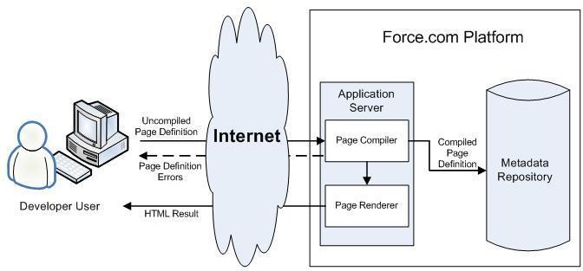

When a developer finishes writing a Visualforce page and saves it to the platform, the platform application server attempts to compile the markup into an abstract set of instructions that can be understood by the Visualforce renderer. If compilation generates errors, the save is aborted and the errors are returned to the developer. Otherwise, the instructions are saved to the metadata repository and sent to the Visualforce renderer. The renderer turns the instructions into HTML and then refreshes the developer's view, thereby providing instantaneous feedback to the developer for whatever changes were made in the markup.

The architecture diagram below shows the process flow when a non-developer user requests a Visualforce page. Because the page is already compiled into instructions, the application server simply retrieves the page from the metadata repository and sends it to the Visualforce renderer for conversion into HTML.

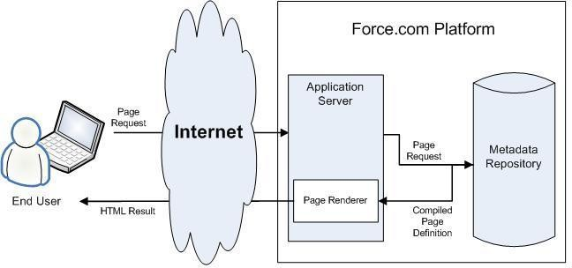

As a markup language, Visualforce provides the following benefits:

## User-friendly development

Developers can edit their Visualforce markup in the same window that displays the resulting page. Consequently, developers can instantly verify the result of an edit just by saving their code. The Visualforce editor pane also includes auto-completion and syntax highlighting.

Visualforce also supports “quick fixes” that allow developers to create supporting components on the fly. For example, a developer can define a new Visualforce page simply by logging in to Salesforce and then entering the name of the new page in a URL. Much like a wiki, if the page does not yet exist, the platform creates it for you.

## Integration with other Web-based user interface technologies

Because Visualforce markup is ultimately rendered into HTML, designers can use Visualforce tags alongside standard HTML, JavaScript, Flash, or any other code that can execute within an HTML page on the platform, including Lightning platform merge fields and expressions.

## Model-View-Controller (MVC) style development

Visualforce conforms to the Model-View-Controller (MVC) development pattern by providing a clear division between the view of an application (the user interface, defined by Visualforce markup), and the controller that determines how the application works (the business logic, defined by a Visualforce controller written in Apex). With this architecture, designers and developers can easily split up the work that goes with building a new application—designers can focus on the look and feel of the user interface, while developers can work on the business logic that drives the app.

## Concise syntax

Visualforce pages can implement the same functionality as s-controls but with approximately 90% fewer lines of code.

## Data-driven defaults

Visualforce components are rendered intelligently by the platform. For example, rather than forcing page designers to use different component tags for different types of editable fields (such as email addresses or calendar dates), designers can simply use a generic

<apex:inputField> tag for all fields. The Visualforce renderer displays the appropriate edit interface for each field.

## Hosted platform

Visualforce pages are compiled and rendered entirely by the Lightning platform. Because they are so tightly integrated, they display the same performance as standard Salesforce pages, regardless of the amount of data being displayed or edited.

Automatically upgradeable

Visualforce pages do not need to be rewritten when other parts of the Lightning platform are upgraded. Because the pages are stored as metadata, they are automatically upgraded with the rest of the system.

# Chapter-3 “Drag N Drop”

## Installation & Configuration Guide

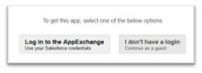

**INTRODUCTION**

Welcome to “Drag N Drop” for Salesforce. This document will guide you through the quick And easy installation and configuration process to help get your teams use Application’s amazing features.

Drag and Drop feature is here to ease the Add Attachment functionality. Now you can add Attachment to any Object in Salesforce by just a click or dragging and dropping it into your Windows’ Browser.

## REQUIREMENTS

* + Works for latest Browsers version of Chrome, Firefox, Internet Explorer and Safari.
  + Does not work in Safari 5 Windows.

## INSTALLING “DRAG N DROP” FOR SALESFORCE

1. To access our App click the following link below or copy and paste it into your browser;

<https://appexchange.salesforce.com/listingDetail?listingId=a0N30000000q6Q1EAI>

1. Select “Get It Now” button.



1. Login with your Salesforce credentials.
2. Ensure that the package name listed is correct.
3. Review the contents and click “**Continue**”.



1. Review the “**Approve Package API Access** ”page and click “**Install**”

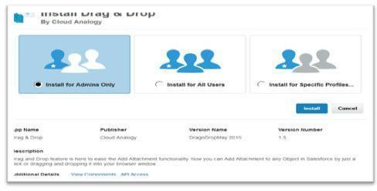

This may take a moment to complete. Once this has finished, you should see the

following message:

1. Click “**Done**”to continue.

You are directed to below Deployed Package Page.

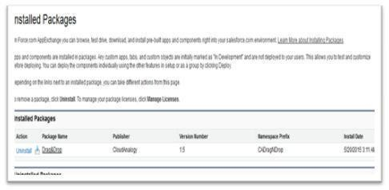

## DRAG N DROP CONFIGURE & DEMO

Before start using Drag N Drop Feature on Custom/Standard Objects, You need to configure for the objects you want to use it.

**STEP: 1**Navigate to **All Tab ‘+’**

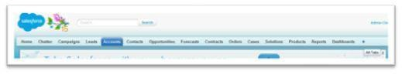

**STEP: 2**Search for **“Drag&Drop Configure”**Tab as shown below:

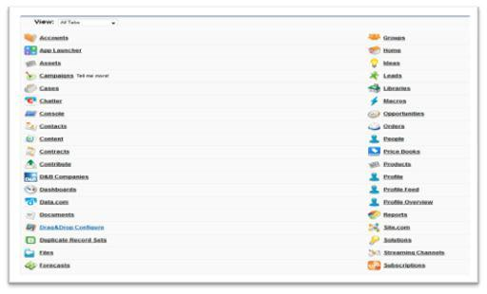

**STEP: 3** After the Below Page appears, you need to click **“Create Remote Site Setting”**

Button.

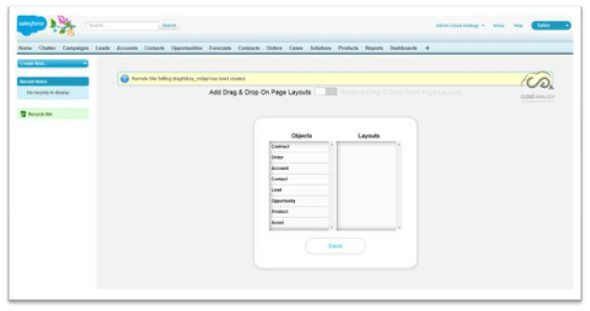

**STEP: 4** Once the **“Remote Site Setting”**automatically configured,success message along with **Drag and Drop Wizard**for adding Drag and Drop feature for respective Object’s page layouts as shown below will appear:

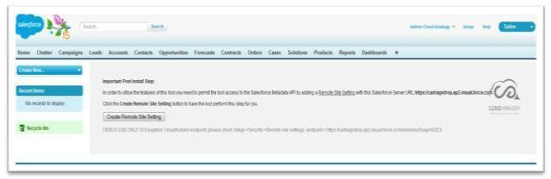

**STEP: 5** For example,Here we have taken Account Object.On selecting Account Object,all the relevant account’s page layout will appear in the layout section.

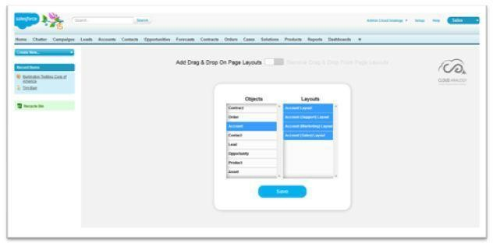

**STEP: 6** After Clicking on “**Save**”button,below success message on top will appear.

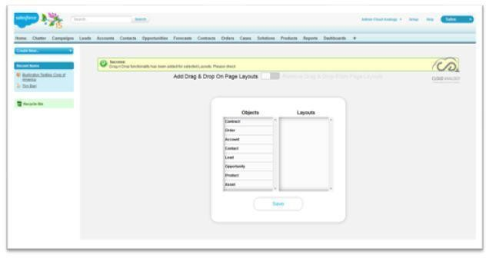

**STEP: 7** Now you can navigate to Account Object and select any record to display the record detail page as shown below:

You can see in the below screen that a section “Add Document” appears automatically.

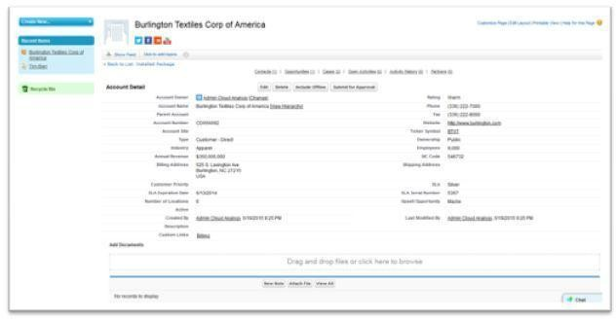

**STEP: 8** Select “**Click here to browse**”option in the add document section,something like below screen appears from where you can directly select the file to attach in “**Notes and Attachments**”section. Now click “**Open**”or simply double click on the file selected.

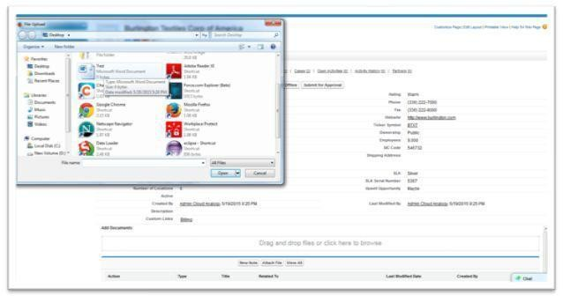

**STEP: 9** File automatically gets uploaded which can be seen in the attachment section just below Add Document

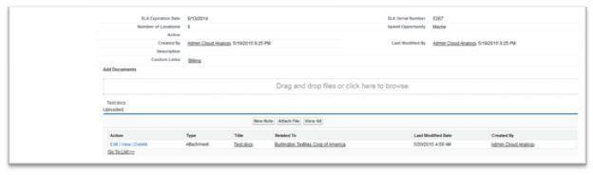

**STEP: 10** Another way to upload is to just simply drag the file from the local system and drop it to the “**Add Document”**Section:

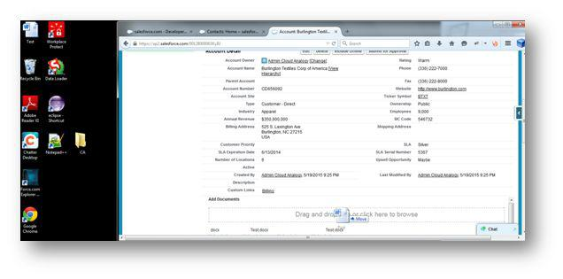

In case you want to remove this feature from some page layouts of objects, you can follow again Step: 1 and Step: 2 and then just click on the button on the right side of slider button placed.

Please note that this button when clicked on Left Side Displays”Add Drag & Drop from Page Layouts”and right side includes “Remove Drag & Drop from Page Layouts”.

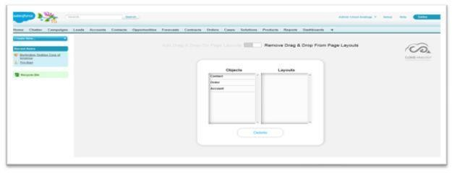

**STEP: 11** Select the Object and its layout from where you want the feature to be removed and select “**Delete**”Button.

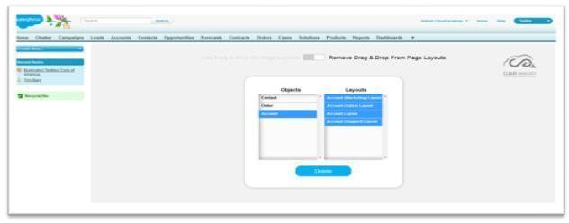





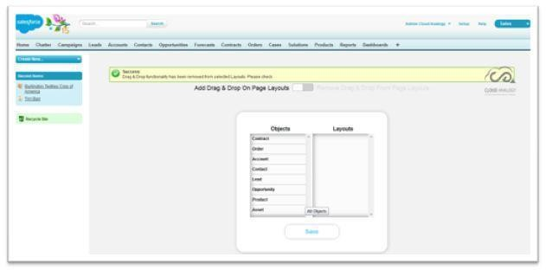**STEP: 12** Below success message appears on selecting the delete button removing the functionality from the selected page layouts.

**STEP: 13** You can cross check once navigating to the same record,the Add documents section automatically gets disappeared.

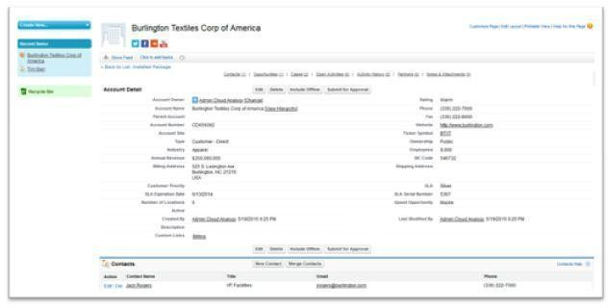

## Demo user Guide

### Drag N Drop Configuration

#### *How To Configure in Salesforce Classic*

Before start using Drag N Drop Feature on Custom/Standard Objects, You need to configure for the objects you want to use it.

**Step1:**Navigate on All tab(+).

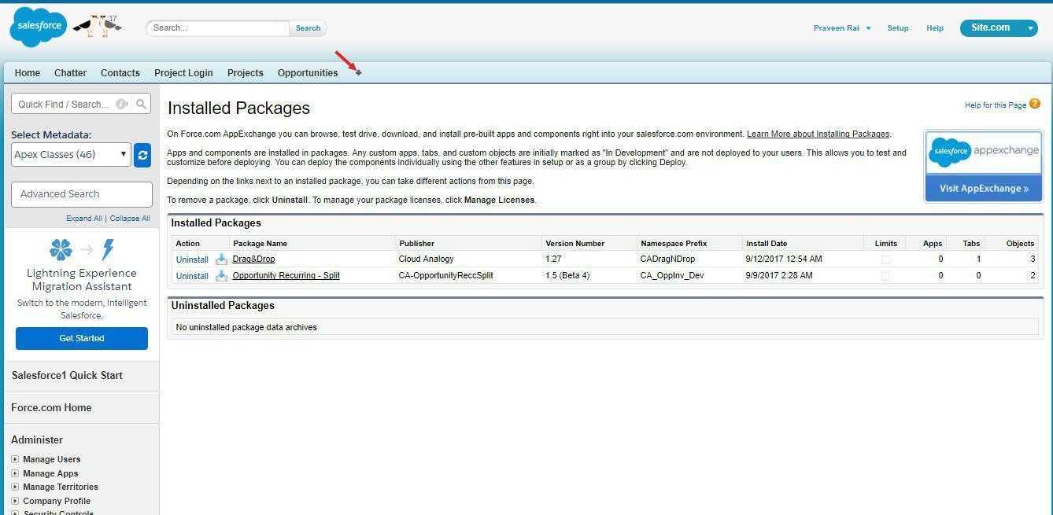

**Step2.** Search for “Drag & Drop Configure” Tab as shown below:

**Step 3.** Now the Drag N Drop Configuration window will shown and and in Layout tab respective object will appears like below:

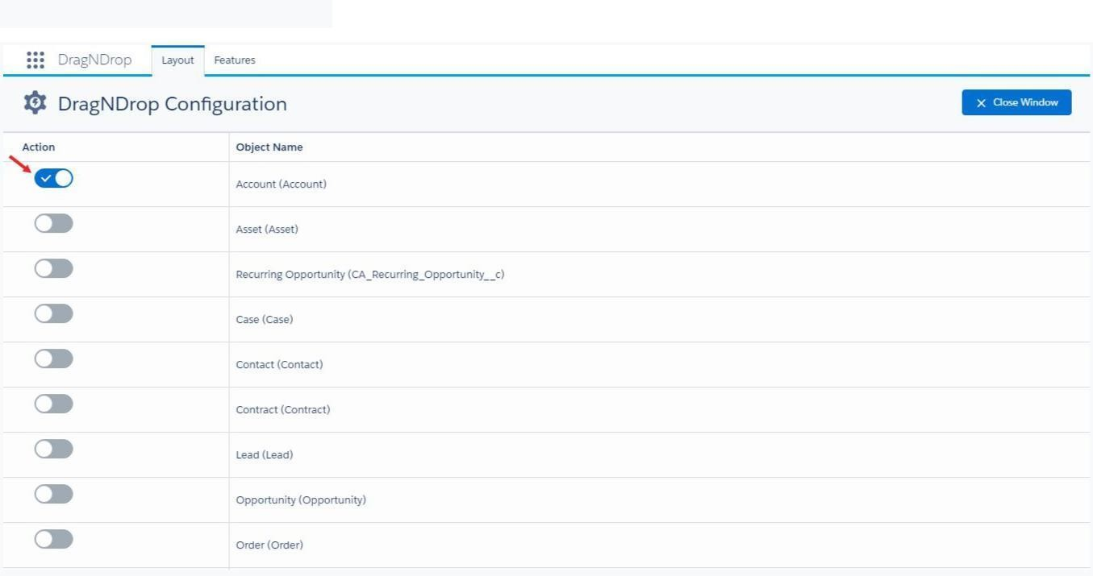

**Forexample:**

Here we have taken Account Object.On selecting Account Object,all the relevant account’s page layout will appear in the layout section.

Note:This wizard enables you to add this feature for custom objects as well.

**STEP4:** After Clicking on **“Save”** button , below success message on top will appear:

You can also enable/disable feature list in the **feature** tab.By default are

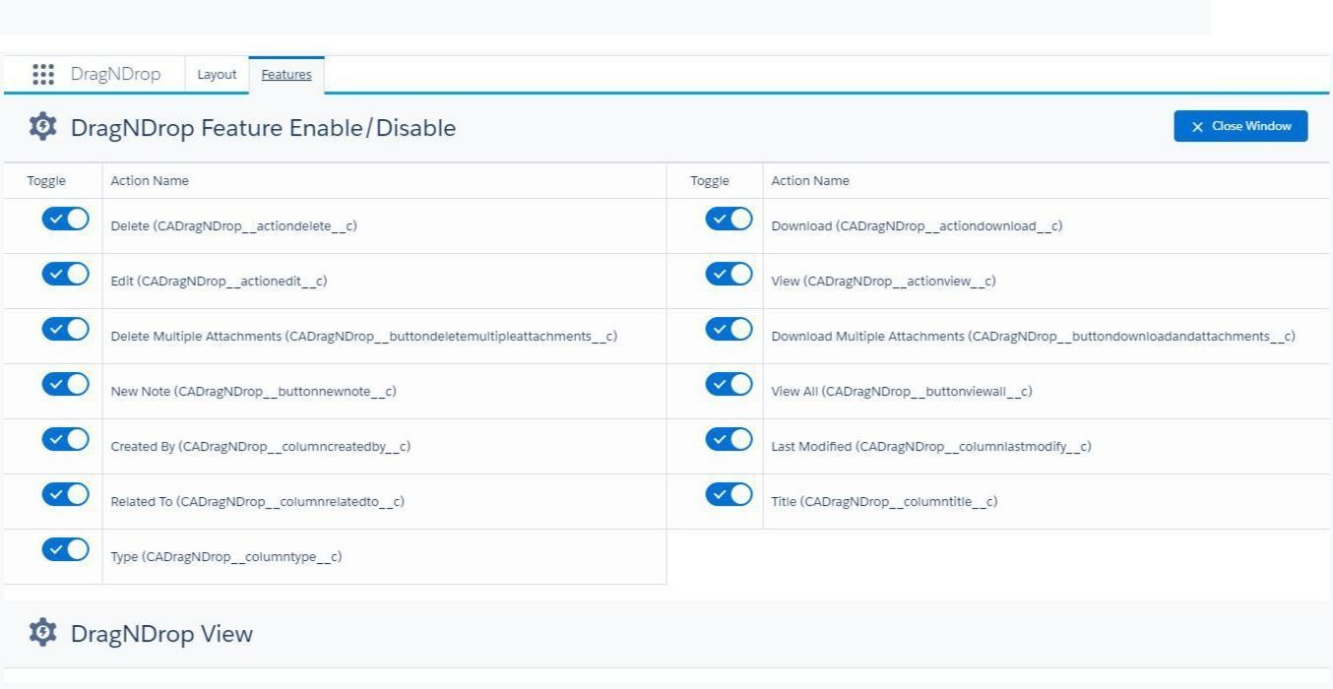

**Step5.** Now you can navigate to Account Object and select any record to display the **record detail page** as shown below and navigate to **Edit Layout** Section:

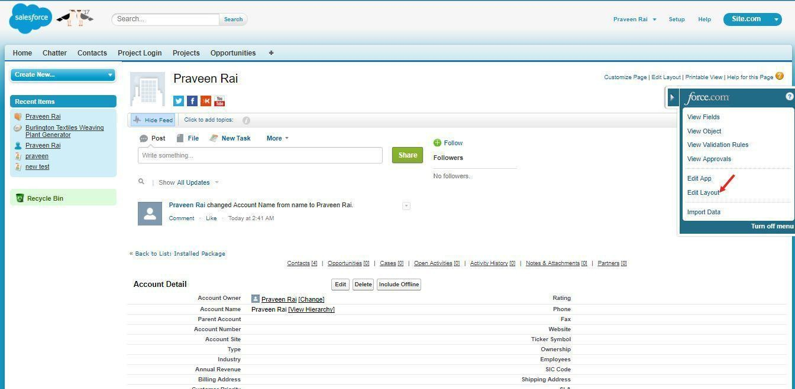

**Step6:**Create a section on Account layout.

And drop the Drag N Drop_Account from Visualforce Pages.And set the height(inpixel)500 of Visualforce page

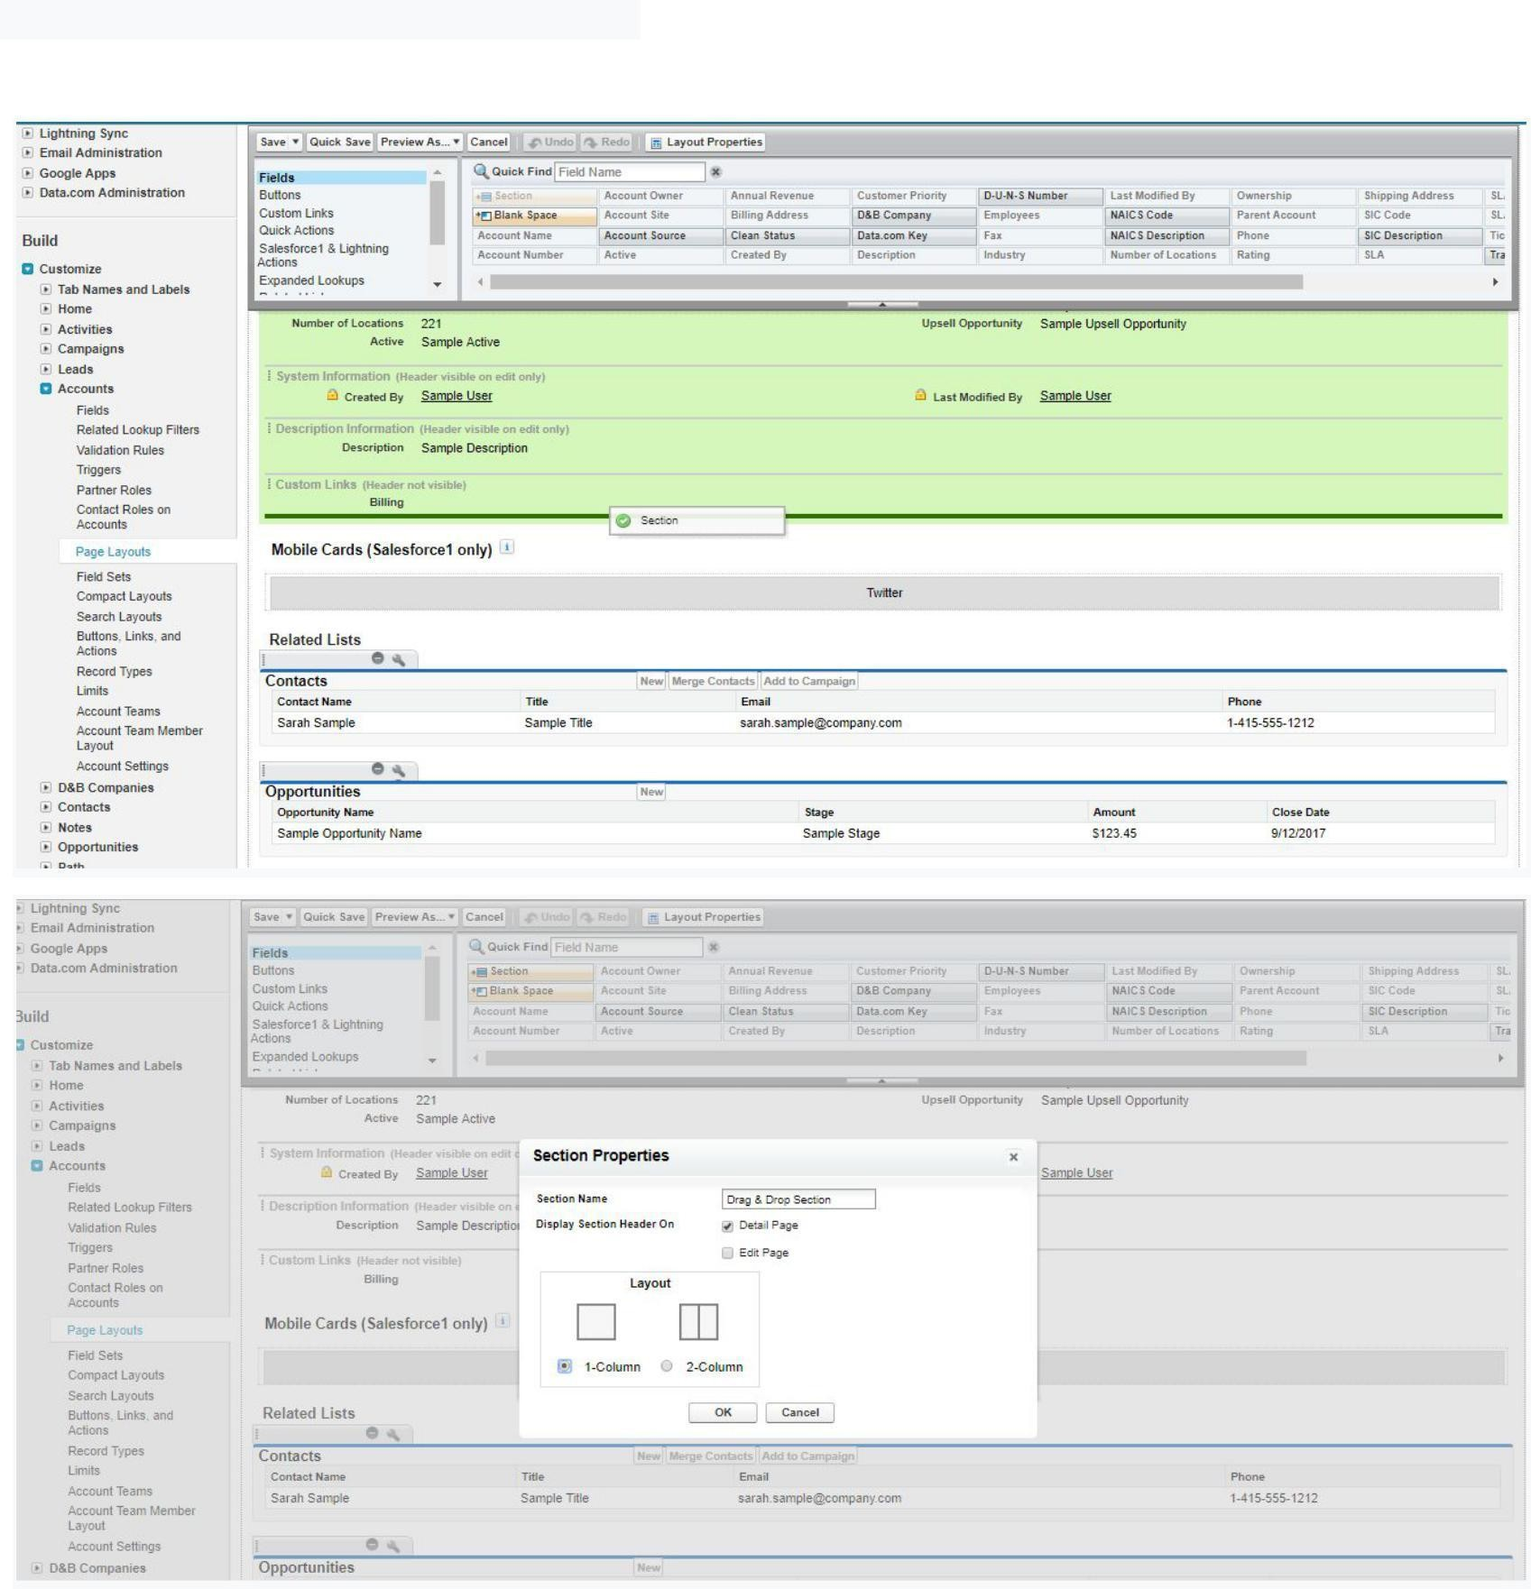

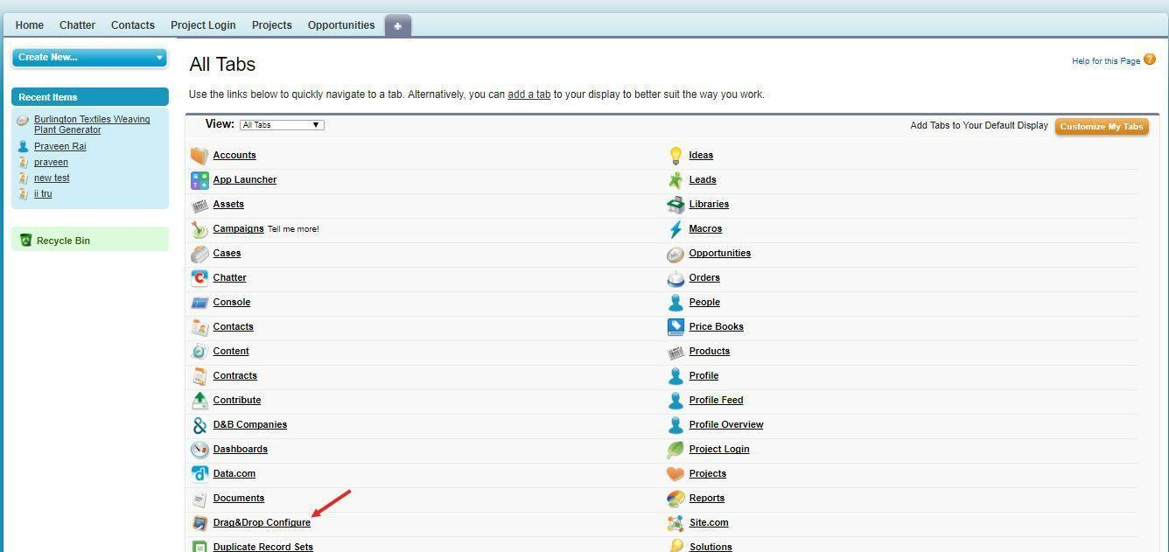

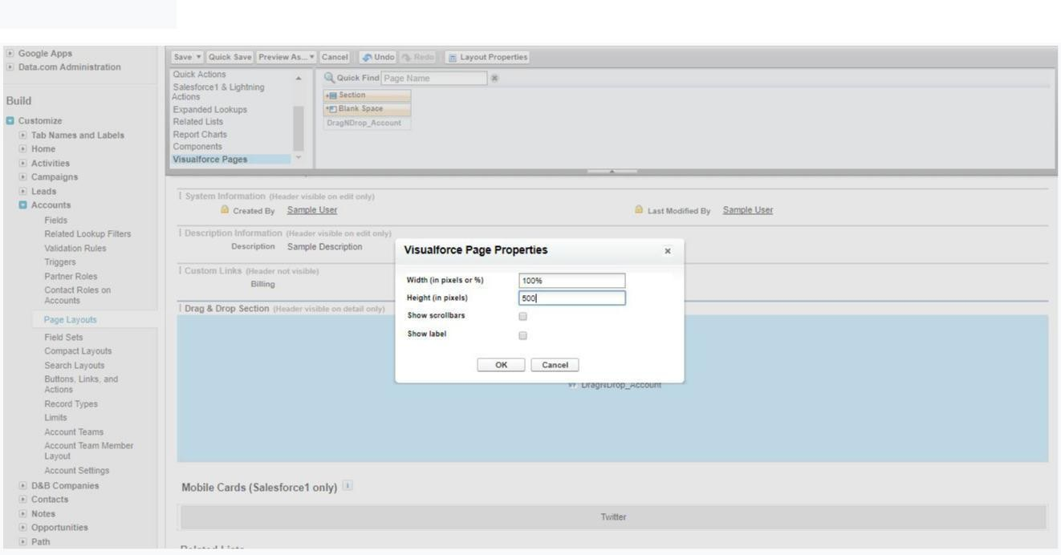



.











Now there cord page will show like below.

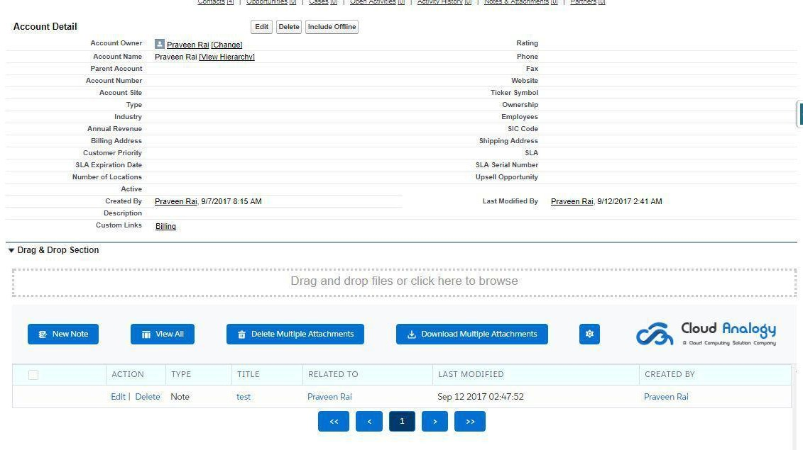

In case you want to remove this feature from some pagelay outs of objects,you can again Follow the Step:3 and Step:4 above,and then just click on theTo Google button on the left Side.

#### *How To Configure in Lightning Experience*

**Step1**: Goto “AppLauncher” and Select “Drag N Drop Configure” Tab.

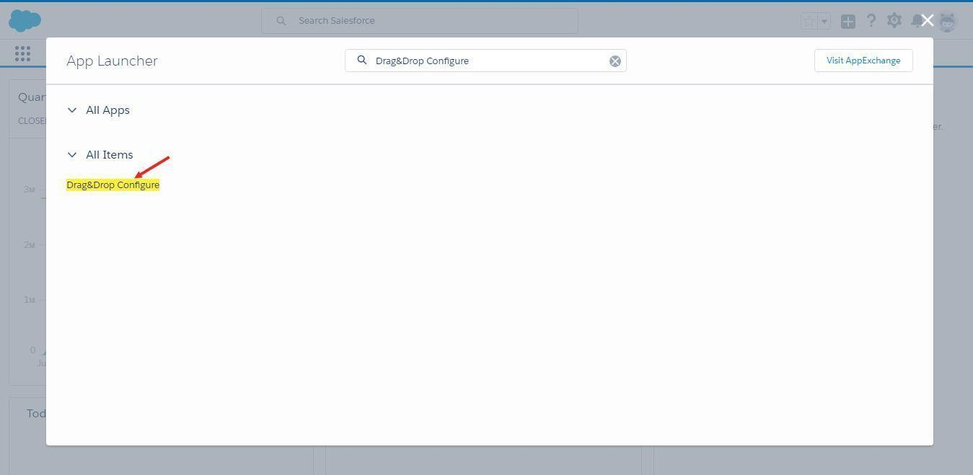

**Step2.** Do same as did in previous Step 3 and Step4.

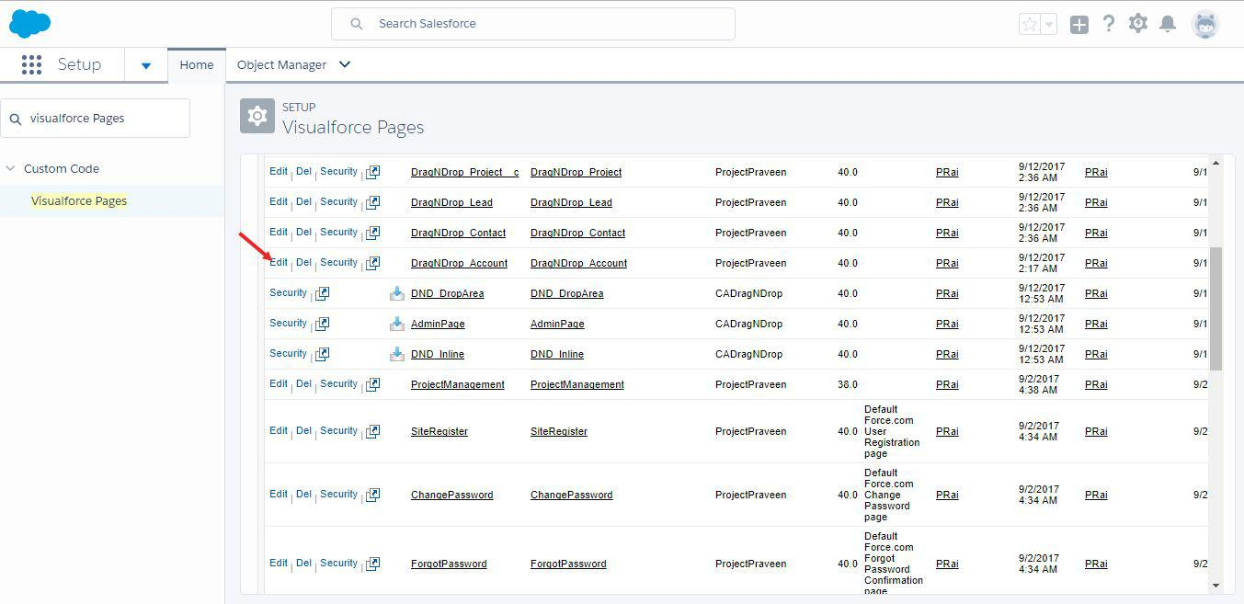

**Step3.** Go to setup and enter the Visualforce Pages. And edit the Drag N Drop Account page Now click on the Available for Salesforce Mobile App and Lightning Pages checkbox.

And Save the page.

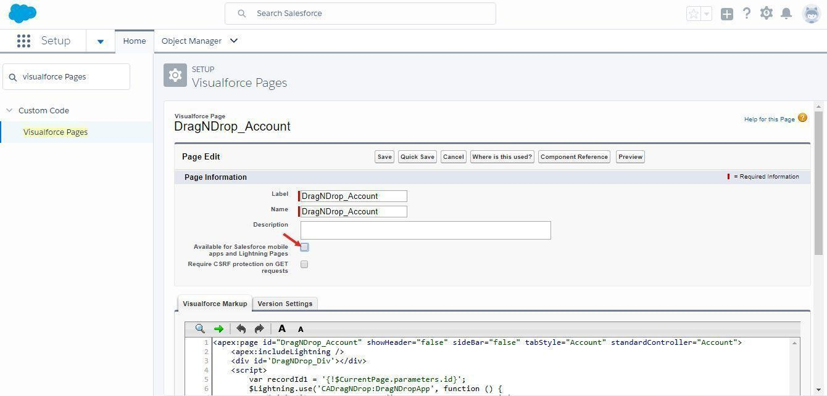

**Step4:** Go to Account Record and click Edit Page from Gear.

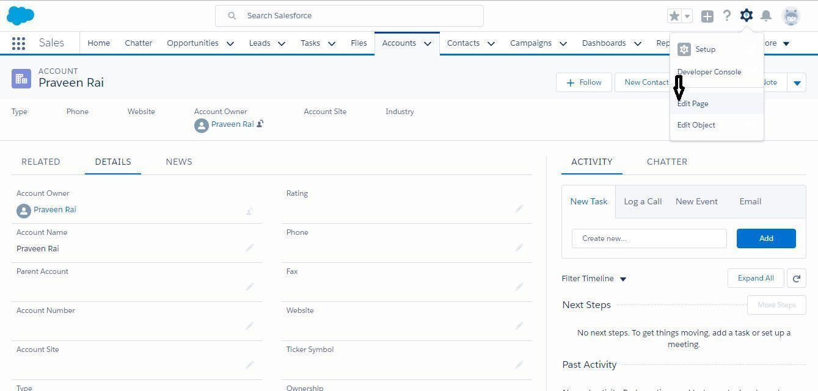

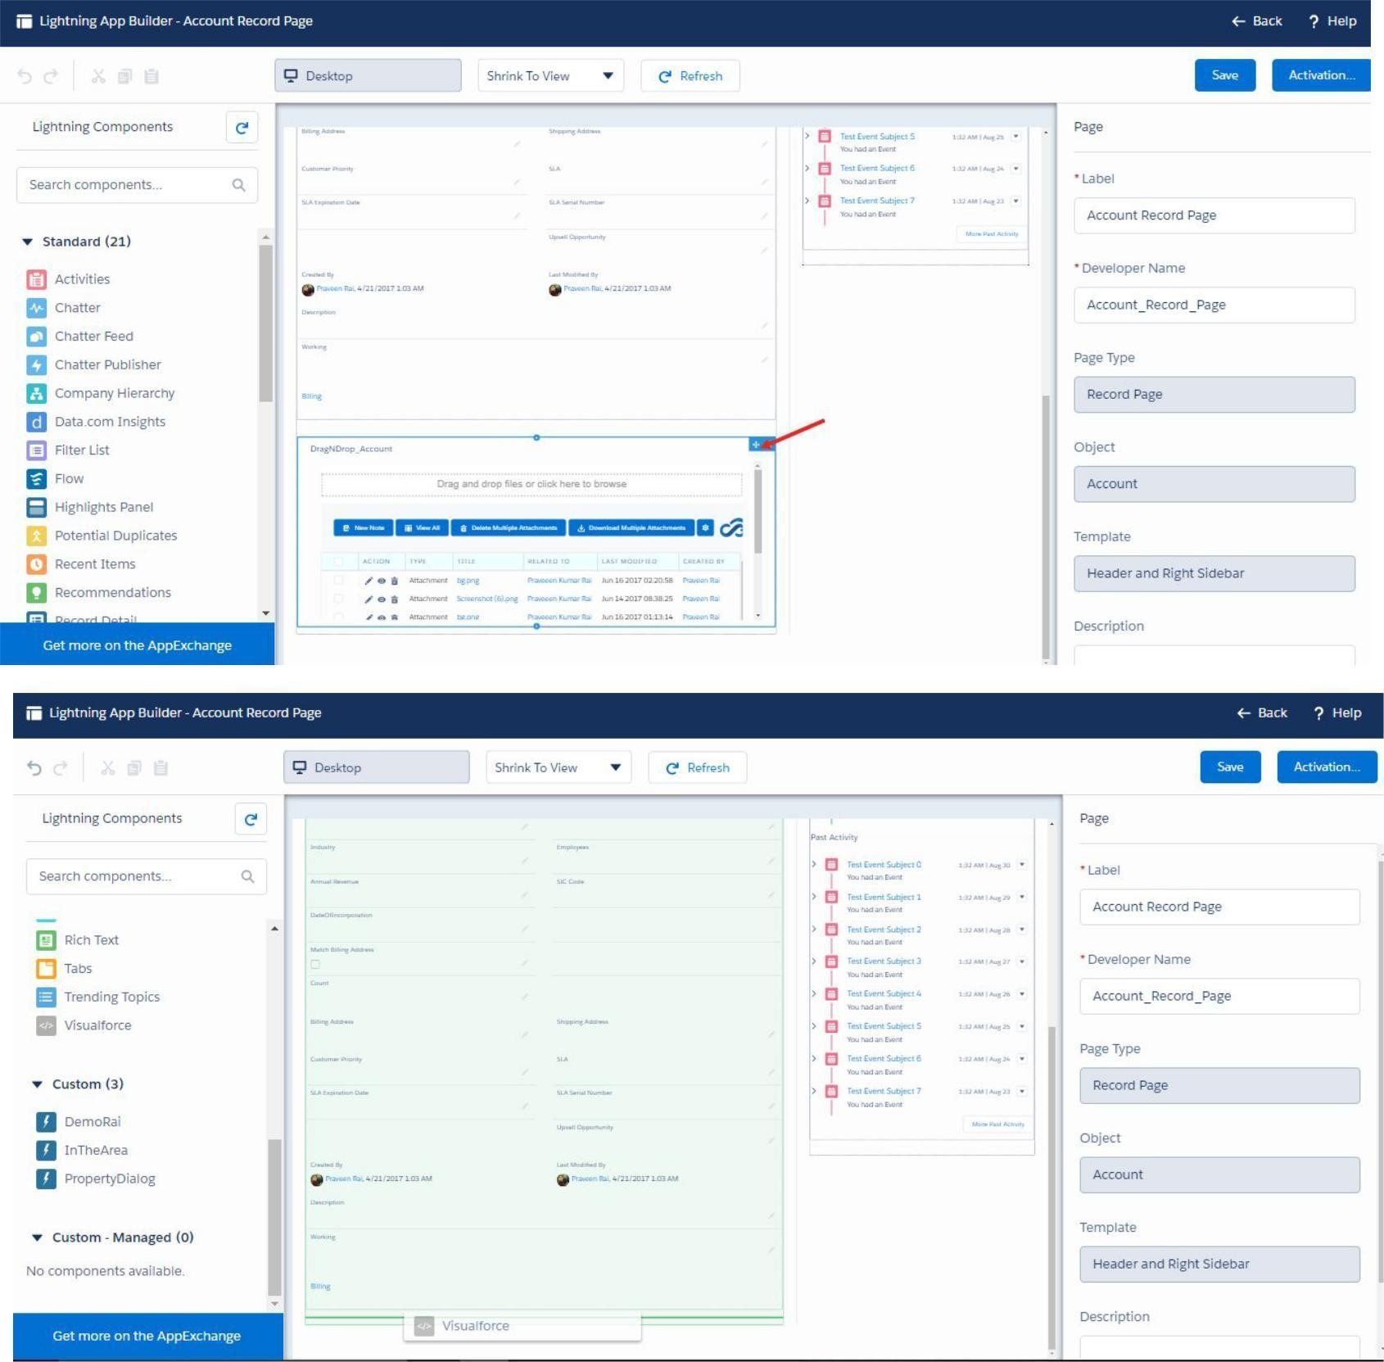

**Step5** : From Standard Component , drag and drop the Visualforce page below the Details Section.

Save the Account record page and Activate for Orgas Default. Now the finally Account record page will look like this.

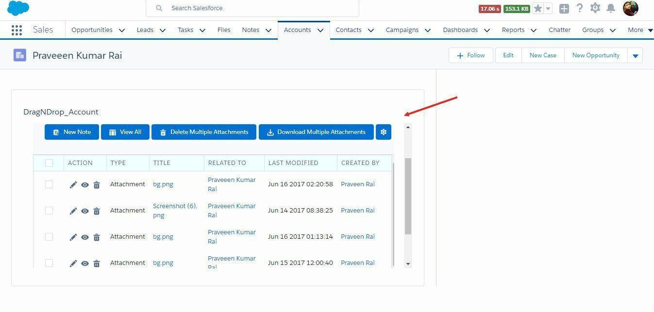

In case you want to remove this feature from some page layouts of objects,you can again

# Manual

## Configuration Guide “Drag N Drop”

**MANUAL CONFIGURATION GUIDE**

### MANUAL CONFIGURATION STEPS:

If the Automatic configuration tab is not working and you can also manually configure the application as following,

**Step 1:** Select the Object you want to configure the steps.

The Standard or Custom Object can be configured to have the Drag N Drop application.

Make sure Attachments are available for that object.

Click on your Name.

Goto Setup

Enter “pages” on Search all Setup left hand quick search

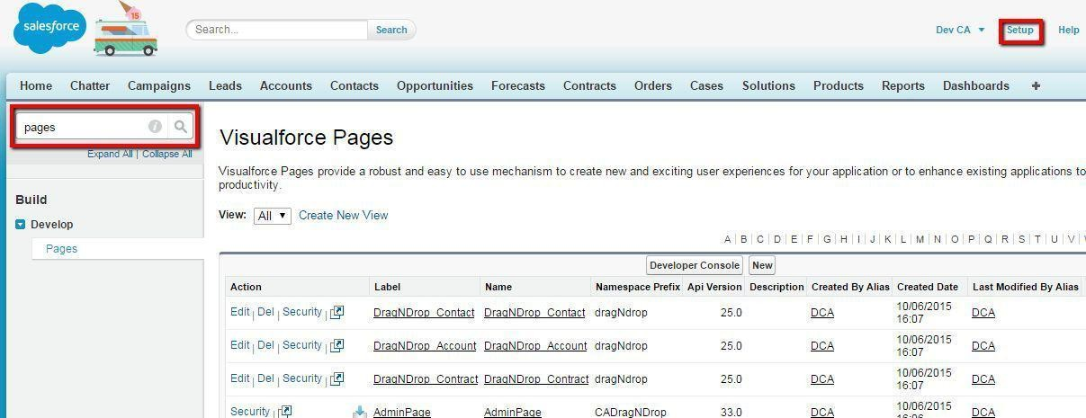

**Step 2:** Create a Visualforce. Name: DragNDrop_ObjectName

Example : DragNDrop_Account for Account Object. Add the following code to the page.

<apex:page

standardController="**Account**"><CADragNDrop:FinalCom ponent parenId="{!$CurrentPage.parameters.Id}"

/></apex:page>

Example : DragNDrop_Opportunity for Opportunity Object.

Add the following code to the page.

<apex:page standardController="**Opportunity**">

<CADragNDrop:FinalComponent parenId="{!$CurrentPage.parameters.Id}" />

</apex:page>

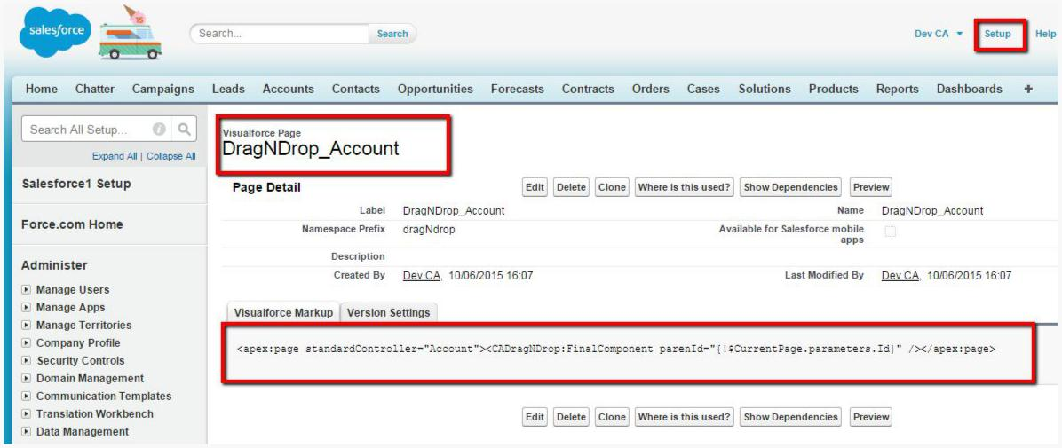

#### Step 3:

* Edit Page layout
* Go to the Object pagelayout which you want to configure.
* Edit the pagelayout
* Add a New Section on the page Layout
* Add the Name of the section “Drag n Drop”
* Select one Column option
* Add Scroll Bars
* On the Edit page Layout Top section goto Visualforcepage.

Select the Visualforce page created in previous step “DragNDrop_Opportunity ” Place this visualforce page in the Section

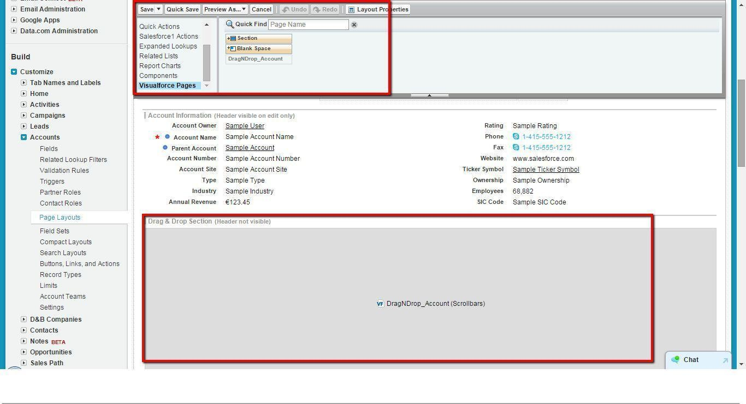

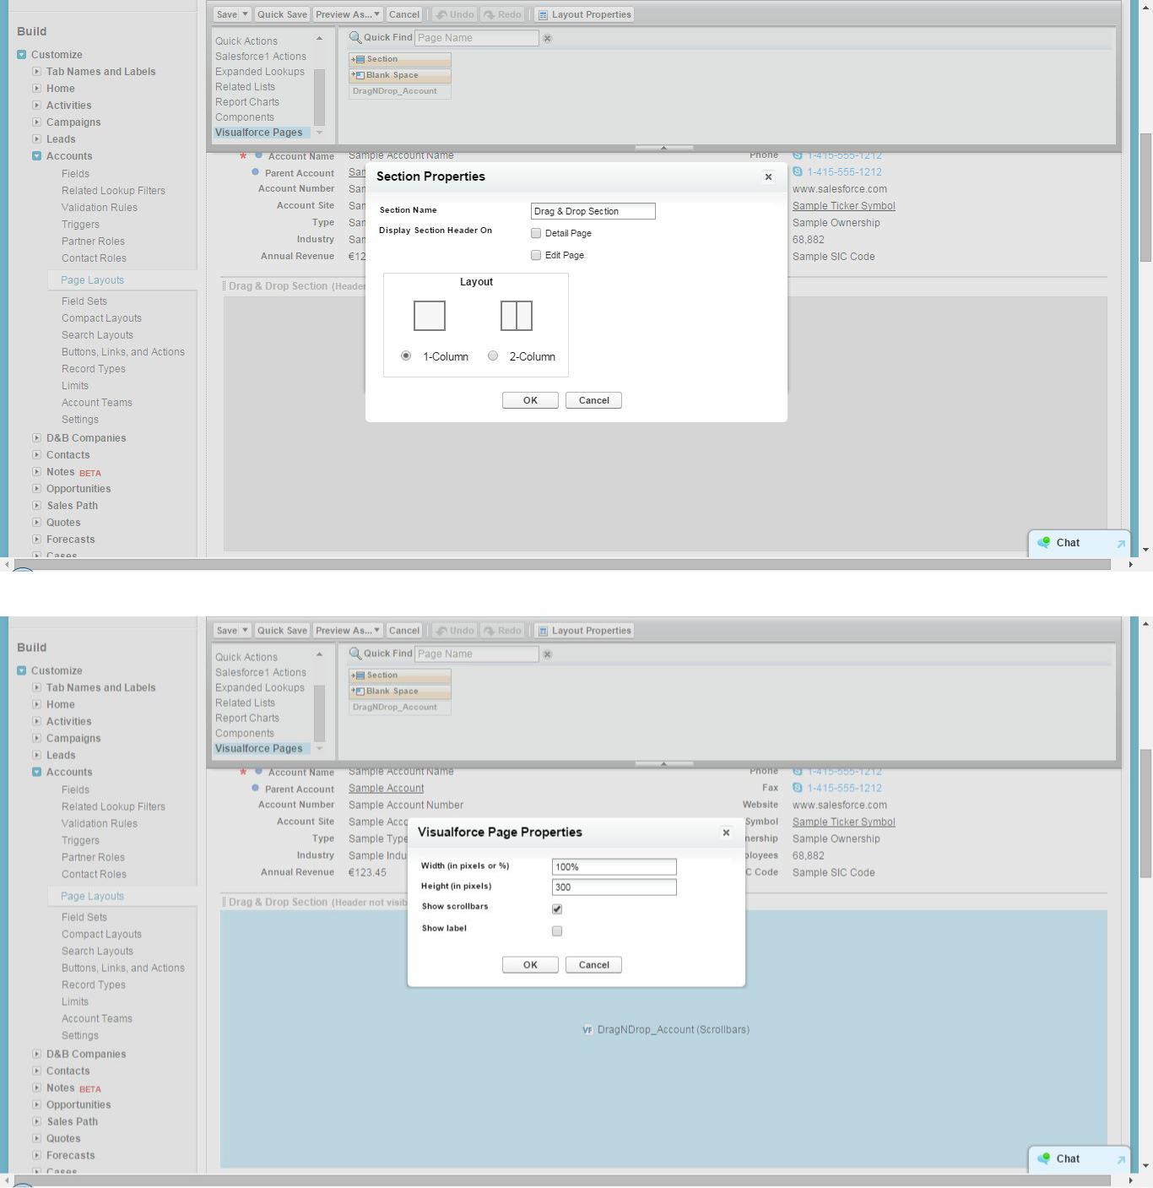

**Step 4:**Open the Object Tab.

Goto the Object Tab open any record detail page.

**CHAPTER- Testing**

**TESTING & DEPLOYMENT**

Software Testing

Software Testing is a critical element of software quality assurance and represents the ultimate review of specification, design and coding. Testing presents an increasingly anomaly for the software engineer.

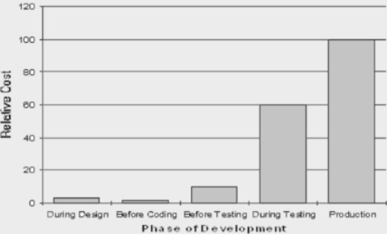

**Testing Objective includes:**

Testing is a process of executing a program with the intent of finding an error.

A good test case is one that has a probability of finding an as yet undiscovered error. A successful test is one that uncovers an undiscovered error.

**Testing Principles:**

All tests should be traceable to end user requirements. Tests should be planned long before testing begins.

Testing should begin on a small scale and programs towards testing in large. Exhaustive testing is not possible.

To be most effective testing should be conducted by an independent third party

**White-Box, Grey-Box and Black-Box Testing**

White box and black box testing are terms used to describe the point of view that a test engineer takes when designing test cases. Black box testing treats the software as a black-box without any understanding as to how the internals behave. Thus, the tester inputs data and only sees the output from the test object. This level of testing usually requires thorough test cases to be provided to the tester who then can simply verify that for a given input, the output value (or behavior), is the same as the expected value specified in the test case.

White box testing, however, is when the tester has access to the internal data structures, code, and algorithms. For this reason, unit testing and debugging can be classified as white-box testing and it usually requires writing code, or at a minimum, stepping through it, and thus requires more skill than the black-box tester. If the software in test is an interface or API of any sort, white-box testing is almost always required.

In recent years the term grey box testing has come into common usage. This involves having access to internal data structures and algorithms for purposes of designing the test cases, but testing at the user, or black-box level. Manipulating input data and formatting output do not qualify as grey-box because the input and output are clearly outside of the black-box we are calling the software under test. This is particularly important when conducting integration testing between two modules of code written by two different developers, where only the interfaces are exposed for test.

Grey box testing could be used in the context of testing a client-server environment when the tester has control over the input, inspects the value in a SQL database, and the output value, and then compares all three (the input, sql value, and output), to determine if the data got corrupt on the database insertion or retrieval.

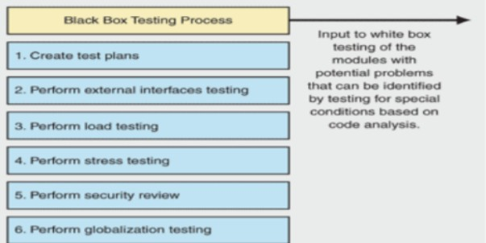

**Verification and Validation**

Software testing is used in association with verification and validation (V&V).Verification is the checking of or testing of items, including software, for conformance and consistency with an associated specification. Software testing is just one kind of verification, which also uses techniques such as reviews, inspections, and walkthroughs. Validation is the process of checking what has been specified is what the user actually wanted.

* + - Verification: Have we built the software right? (i.e. does it match the specification).
    - Validation: Have we built the right software? (i.e. Is this what the customer wants?)

**Test Cases**

* + - Unit testing tests the minimal software component, or module. Each unit (basic component) of the software is tested to verify that the detailed design for the unit has been correctly implemented. In an Object-oriented environment, this is usually at the class level, and the minimal unit tests include the constructors and destructors.
    - Integration Testing exposes defects in the interfaces and interaction between integrated components (modules). Progressively larger groups of tested software components corresponding to elements of the architectural design are integrated and tested until the software works as a system.
    - Functional testing tests at any level (class, module, interface, or system)for proper functionality as defined in the specification.
    - System testing tests a completely integrated system to verify that it meets its requirements.
    - System integration testing verifies that a system is integrated to any external or third party systems defined in the system requirements.
    - Acceptance testing can be conducted by the end-user, customer, or client to whether or not to accept the product. Acceptance testing may be performed as part of the hand-off process between any two phases of development.
    - Alpha testing is simulated or actual operational testing by potential users/customers or an independent test team at the developers' site. Alpha testing is often employed for off-the-shelf software as a form of internal acceptance testing, before the software goes to beta testing.
    - Beta testing comes after alpha testing. Versions of the software, known as beta versions, are released to a limited audience outside of the company. The software is released to groups of people so that further testing can ensure the product has few faults or bugs. Sometimes, beta versions are made available to the open public to increase the feedback field to a maximal number of future users. It should be noted that although both Alpha and Beta are referred to as testing it is in fact use immersion. The rigors that are applied are often unsystematic and many of the basic tenets of testing process are not used. The Alpha and Beta period provides insight into environmental and utilization conditions that can impact the software.

After modifying software, either for a change in functionality or to fix defects, a regression test re-runs previously passing tests on the modified software to ensure that the modifications haven't unintentionally caused a regression of previous functionality. Regression testing can be performed at any or all of the above test levels. These regression tests are often automated.

**SMOKE TESTING**

Smoke testing is a term used in plumbing, woodwind repair, electronics, and computer software development. It refers to the first test made after repairs or first assembly to provide some assurance that the system under test will not catastrophically fail. After a smoke test proves that the pipes will not leak, the keys seal properly, the circuit will not burn, or the software will not crash outright, the assembly is ready for more stressful testing.

* + - In plumbing, a smoke test forces actual smoke through newly plumbed pipes to find leaks, before water is allowed to flow through the pipes.
    - In woodwind instrument repair, a smoke test involves plugging one end of an instrument and blowing smoke into the other to test for leaks. (This test is no longer in common use)
    - In electronics, a smoke testing is the first time a circuit is attached to power, which will sometimes produce actual smoke if a design or wiring mistake has been made.
    - In computer programming and software testing, smoke testing is a preliminary to further testing, which should reveal simple failures severe enough to reject a prospective software release. In this case, the smoke is metaphorical.

**IMPLEMENTATION STRATEGY**

The implementation phase involves installing approved applications into production environments. Primary tasks include announcing the implementation schedule, training end users, and installing the product. Additionally, organizations should input and verify data, configure and test system and security parameters, and conduct

post-implementation reviews. Management should circulate implementation schedules to all affected parties and should notify users of any implementation responsibilities.

After organizations install a product, pre-existing data is manually input or electronically transferred to a new system. Verifying the accuracy of the input data and security configurations is a critical part of the implementation process. Organizations often run a new system in parallel with an old system until they verify the accuracy and reliability of the new system. Employees should document any programming, procedural, or configuration changes made during the verification process.

For implementation of the website project:

* 1. The website can be installed on a computer or a server which has PHP and MYSQL installed in it.
  2. The owners of the website are to be properly trained to use all the features of the website, giving details of each features of the website.
  3. To show the accuracy of the website and conformance of the website to the requirements of the owners or users of the website.

**TEST PLAN**

The testing phase requires organizations to complete various tests to ensure the accuracy of programmed code, the inclusion of expected functionality, and the interoperability of applications and other network components. Thorough testing is critical to ensuring systems meet organizational and end-user requirements. Test plans created during initial project phases enhance an organization’s ability to create detailed tests.

A bottom-up approach tests smaller components first and progressively adds and tests additional components and systems. A top-down approach first tests major components and connections and progressively tests smaller components and connections.

Bottom-up tests often begin with functional (requirements based) testing. Functional tests should ensure that expected functional, security, and internal control features are present and operating properly. Testers then complete integration and end-to-end testing to ensure application and system components interact properly. Users then conduct acceptance tests to ensure systems meet defined acceptance criteria.

Organizations should review and complete user, operator, and maintenance manuals during the testing phase. Additionally, they should finalize conversion, implementation, and training plans.

For testing of the website:

1. All the features of the website are tested by running each function available in the website.
2. The results of the tests conducted on the website are analyzed properly. Only after getting satisfactory results of testing the website can be uploaded on the network

i.e. internet.

These are the test cases :

1. Title: Download from Appexchange – Successfully installed for all the user.

Description: A user having a salesforce account can install it for the production or the sandbox.

Precondition: the user must already be having a salesforce account . Assumption: a supported browser is being used.

Test Steps:

* 1. Navigate to Appexchange
  2. Look for information about the application.
  3. Click the ‘Get it Now’ button.
  4. Enter the password of the Salesforce account and choose for the production or sandbox.
  5. Enter Additional information.
  6. Now Click on “Install for Admins” or “Install for users”

Expected Result: Now we can see the installed package for the Drag and drop.

1. Title: Add it for Objects like Account, Contact, and Opportunity Description: Salesforce objects can access drag and drop features. Precondition: the user needs to do the remote site setting in the Org. Assumption: a supported browser is being used.

Test Steps:

* 1. Go to sales, on tabs select +
  2. Select the drag and drop Configuration.
  3. Click on it.
  4. Check for the Drag and drop View and features.

Expected Result: Drag and drop will be added on the objects mentioned.

.

1. Title: We will add the Drag and drop view on the Account. Description: Account can access drag and drop features. Precondition: Need a record on which a file needs to be added. Assumption: a supported browser is being used.

Test Steps:

1. Go to sales, on tabs select Account, Here we have taken Account Object. On selecting Account Object, all the relevant account’s page layout will appear in the layout section
2. Go to Setup, then account page layout adding the Drag and drop from the Vf page.. 3.Now Upload a file in the Account regarding to it.
3. Now you can navigate to Account Object and select any record to display the record detail page as shown below: You can see in the below screen that a section “Add Notes ” “New Note” “Download Multiple attachment ”appears automatically in the Page Layout

=.

1. Now you can see the added file in the Notes and Attachment of the Account object.

Expected Result: Drag and drop will now help you to attach documents at ease.

4.Title: We will add the Drag and drop view on the Contact. Description: Contact can access drag and drop features. Precondition: Need a record on which a file needs to be added. Assumption: a supported browser is being used.

Test Steps:

1. Go to sales, on tabs select Contact, Here we have taken Contact Object. On selecting Contact Object, all the relevant Contact’s page layout will appear in the layout section
2. Go to Setup, then Contact page layout adding the Drag and drop from the Vf page.. 3.Now Upload a file in the Contact regarding to it.
3. Now you can navigate to Contact Object and select any record to display the record detail page as shown below: You can see in the below screen that a section “Add Notes

” “New Note” “Download Multiple attachment ”appears automatically in the Page Layout

=.

1. Now you can see the added file in the Notes and Attachment of the Contact object.

Expected Result: Drag and drop will now help you to attach documents at ease.

5.Title: We will add the Drag and drop view on the Lead. Description: Lead can access drag and drop features. Precondition: Need a record on which a file needs to be added. Assumption: a supported browser is being used.

Test Steps:

1. Go to sales, on tabs select Lead, Here we have taken Lead Object. On selecting Lead Object, all the relevant Lead’s page layout will appear in the layout section 2.Go to Setup, then Lead page layout adding the Drag and drop from the Vf page.. 3.Now Upload a file in the Lead regarding to it.

1. Now you can navigate to Lead Object and select any record to display the record detail page as shown below: You can see in the below screen that a section “Add Notes ” “New Note” “Download Multiple attachment ”appears automatically in the Page Layout

=.

1. Now you can see the added file in the Notes and Attachment of the Lead

object.

Expected Result: Drag and drop will now help you to attach documents at ease.

4.Title: We will add the Drag and drop view on the Opportunity. Description: Opportunity can access drag and drop features. Precondition: Need a record on which a file needs to be added. Assumption: a supported browser is being used.

Test Steps:

1. Go to sales, on tabs select Opportunity, Here we have taken Opportunity Object. On selecting Opportunity Object, all the relevant Opportunity’s page layout will appear in the layout section
2. Go to Setup, then Opportunity page layout adding the Drag and drop from the Vf page..
3. Now Upload a file in the Opportunity regarding to it.
4. Now you can navigate to Opportunity Object and select any record to display the record detail page as shown below: You can see in the below screen that a section “Add Notes ” “New Note” “Download Multiple attachment ”appears automatically in the Page Layout =.
5. Now you can see the added file in the Notes and Attachment of the Opportunity object.

Expected Result: Drag and drop will now help you to attach documents at ease.

# Overview

Drag & Drop app is helpful in saving lots of time, lots of hard work to Downlod , upload and delete files ,attachments.

Drag and Drop feature is here to ease in followings**:**

**ANY OBJECT CONFIGURATION :** Drag N Drop is designed to utilize Salesforce Attachments & Notes feature enabled for any Standard or Custom Object.

**FEATURE CONFIGURATION :** All the features in Drag n Drop will been abled by default.You can limit certain features as per your organizational needs.

**DRAG N DROP :** Salesforce 3 steps process of adding files to attachments is replacedby this one steppro.

**DELETE MULTIPLE :** Deleting one file at a time can be very tedious and with multiple selection logic the applet the user to delete multiple files together.

**DOWNLOAD MULTIPLE :** At times you need to download multiple files quickly. Drag and Drop provides this Facility.